UNIQUE Forestry and Land Use by GmbH

ИЗВЕШТАЈ

Пројекат ''Програм активности за подршку реализацији пројекта Имплементација иновативног планирања газдовања шумама уз поштовање економских, еколошких и друштвених аспеката у Србијиˮ, представља наставaк и саставни део билатералног пројекта ''Развој и увођење иновативног концепта планирања газдовања шумама уз поштовање економских, еколошких (заштита од поплава, ледолома и пожара) и социјалних аспеката у Србији'', финансираног од стране Министарства пољопривреде и заштите животне средине Републике Србије и Савезног министарство за храну и пољопривреду Немачке.
Реализатор горе наведеног билатералног српско-немачког пројекта јесте фирма UNIQUE Forestry and Land Use by GmbH. Како је пројекат организован као део горе поменутог српско-немачког пројекта, пожељна је експертиза из Немачке и земаља са веома сличном методологијом., те је стога ова фирма је ангажована и од стране Факултета – реализатора и корисника средстава у процесу финансирања дела пројекта Министарства пољопривреде и заштите животне средине – (Управа за шуме) Републике Србије (Уговор бр. 401-00-1877 / 2016-10 од 18.07.2016.год.) за следеће услуге:
- 2-1: Мапирање Шумских Станишта
- 9-1: Развој Мапирања Функција Шума као независна активност подршке ПРШ и ПГШ (План Развоја Шума и Планирање Газдовања Шумама)

У оквиру Пријаве Шумарског факултета на расписани конкурс за израду Пројекта: „Програм активности за подршку реализацији пројекта Имплементација иновативног планирања газдовања шумама уз поштовање економских, еколошких и друштвених аспеката у Србијиˮ, у делу који се односи на Образложење значаја пројектних активности, у задњем пасусу стоји следеће:
'' … Резултати имплентације Пројекта, у великој мери произашли кроз активности у оквиру две радионице (Workshops), које ће бити организоване и вођене од стране тима иностраних експерата у области природи блиског газдовања, раста и производности шума мапирања шумских станишта функција и подручја под скорашњим и некадашњим интензивним ерозионим процесима, као и економичности и функционалности унапређених различитих планова газдовања, требају створити неопходну базу нових информација од значаја за даљи развој шумарског и низа других сектора ослоњених на шумарство…''
Стога су за сваки од претходно наведених задатака спроведене радионице, са учешћем домаћих и интернацуионалних истраживача, ангажованих од стране UNIQUE Forestry and Land Use by GMBH. У начелу, реализоване су по једна радионица, односно комбинација радионице и одласка на терен и наведене услуге чине део Пројекта Шумарског факултета, који је саставни део овог Уговора између Шумарског факултета у Београду и поменуте фирме.
Радионице су одржане у више наврата, сходно претпостављеним задацима и динамици реализације Пројекта. Координацију свих активности страних експерата на овом Пројекту вршио је Axel Weinreich.

РАДИОНИЦЕ: УЧЕСНИЦИ, ЗАДУЖЕЊА, ДАТУМИ БОРАВКА И ФОТО-ДОКУМЕНТАЦИЈА

Датуми и спискови учесника неких од радионица:



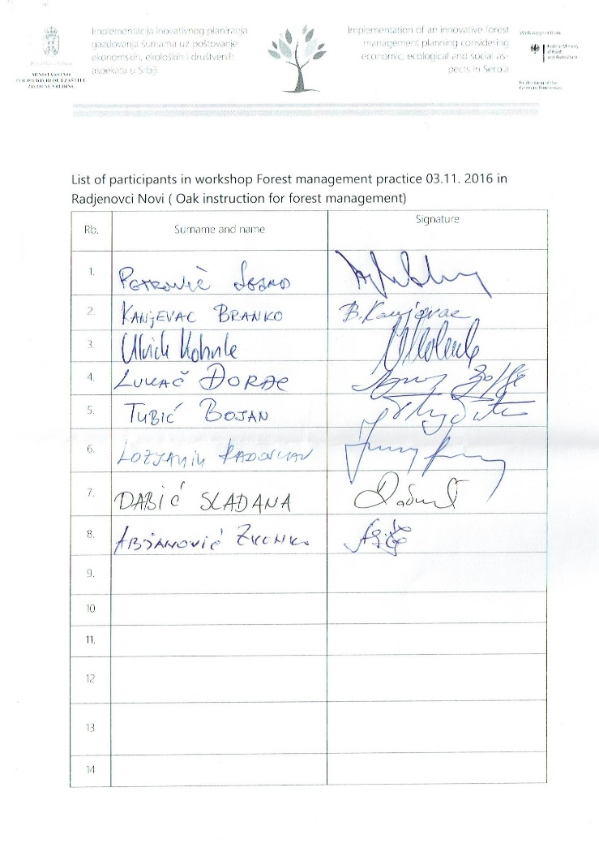

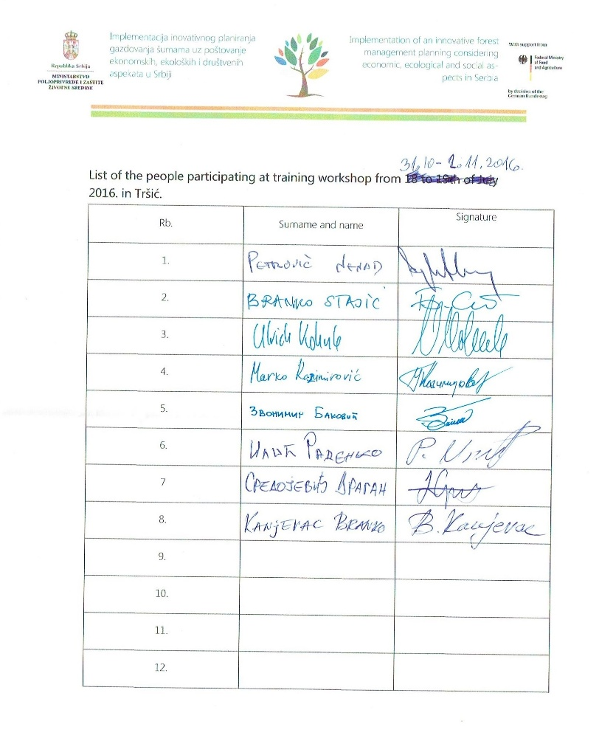

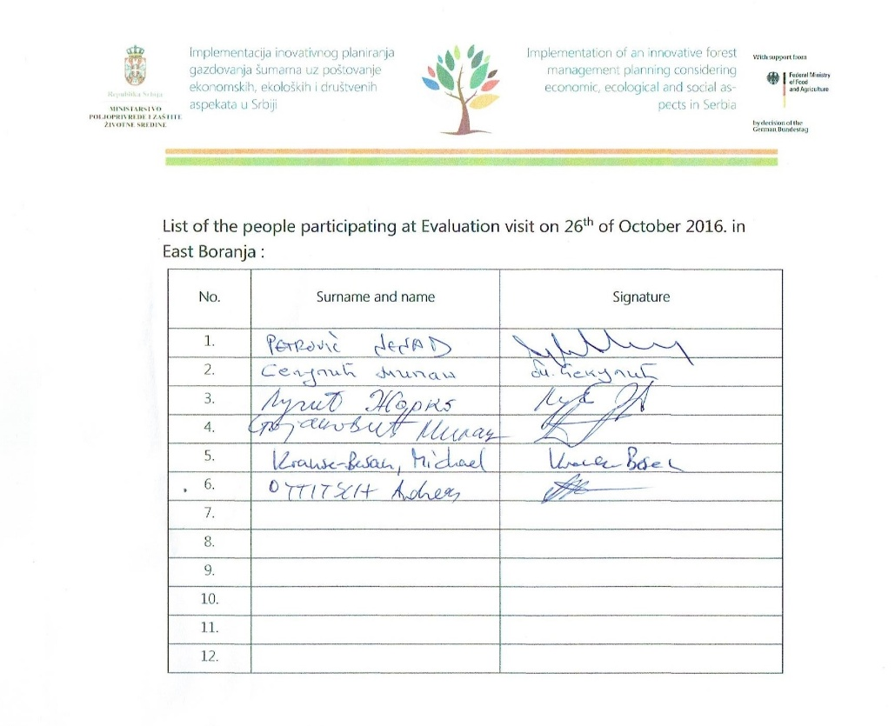



ФОТО – ДОКУМЕНТАЦИЈА СА ПРОВЕДЕНИХ РАДИОНИЦА

Поље унапређења 1- Пракса планирања газдовања шумама
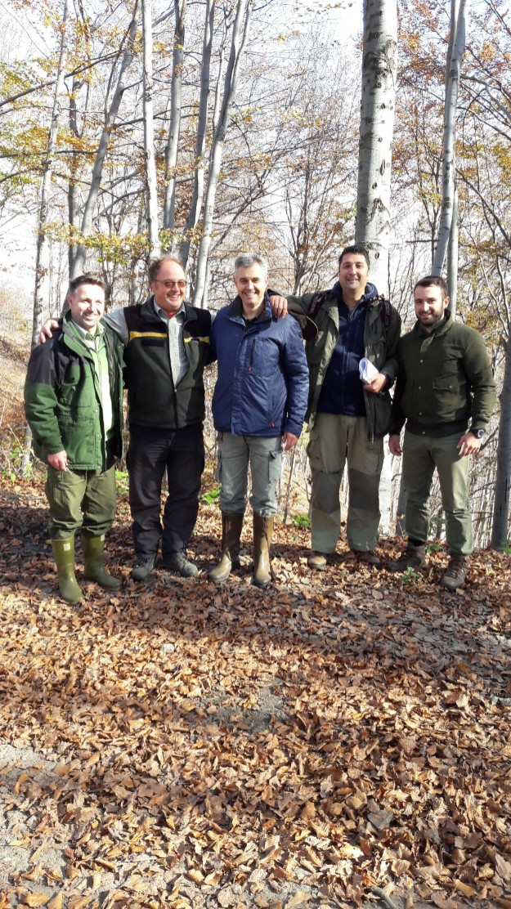
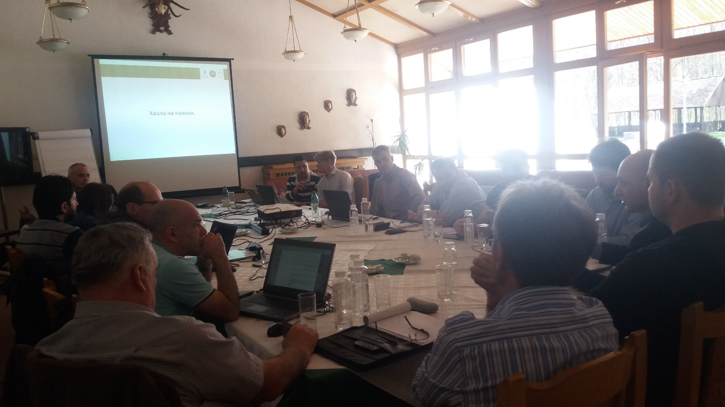
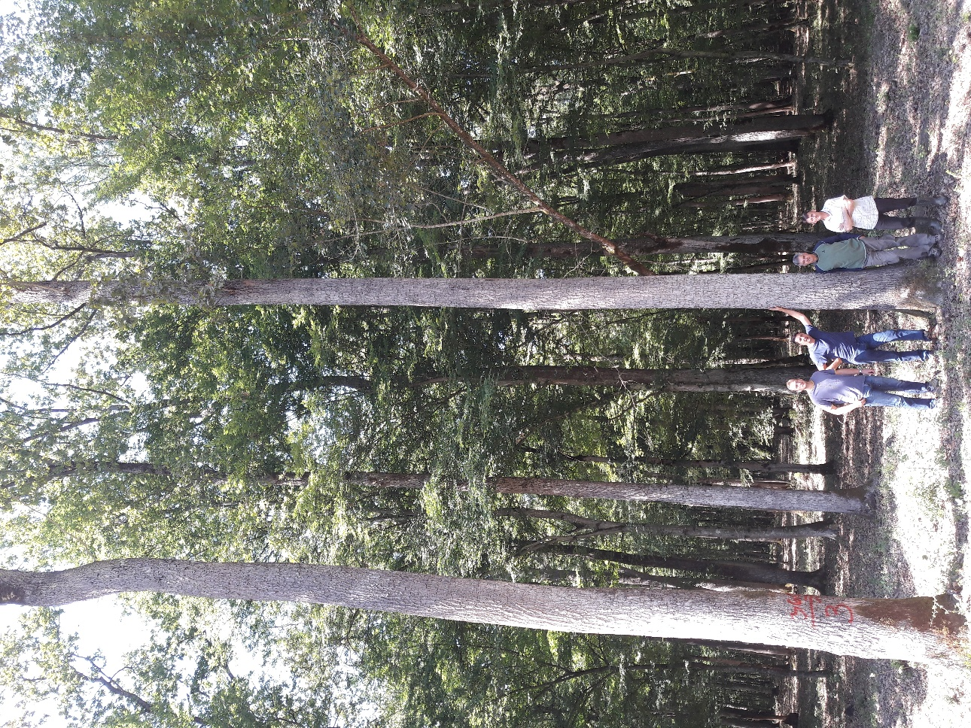

Поље унапређења 2- Шумска станишта и воде
Радионица (канцеларијска и теренска активност) – 8 слика
Датум: 06.10.2017-08.10.2017. године

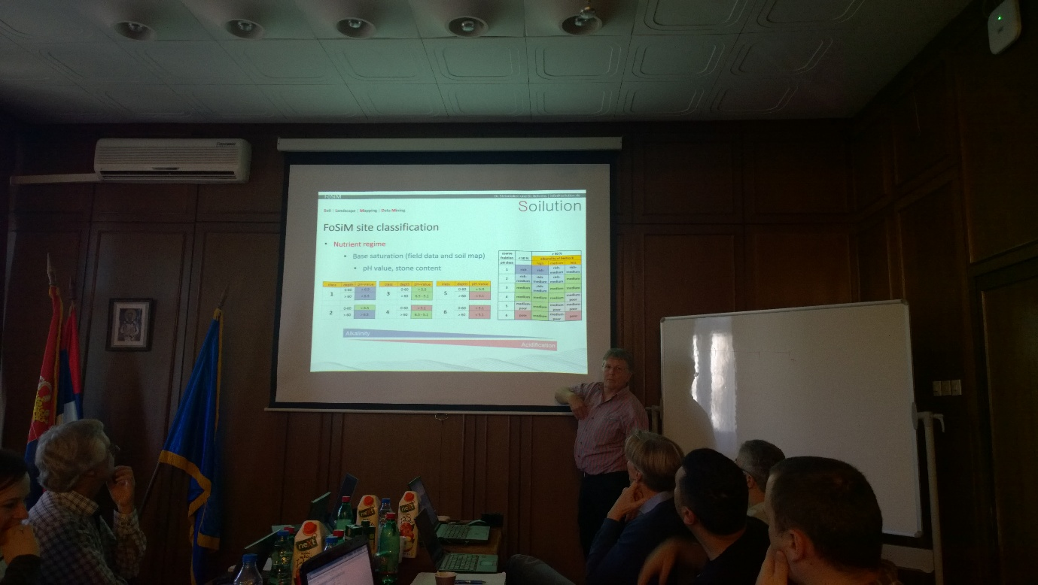
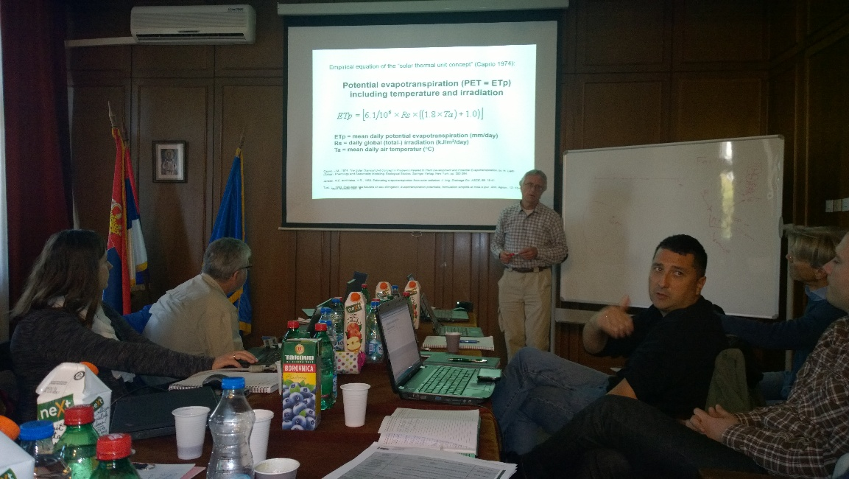
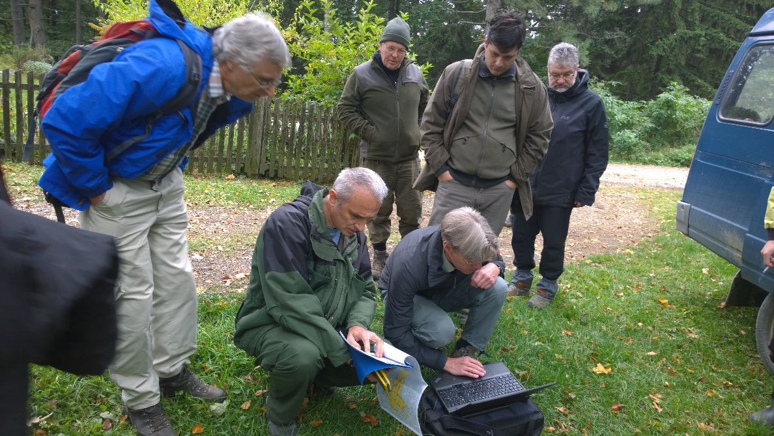

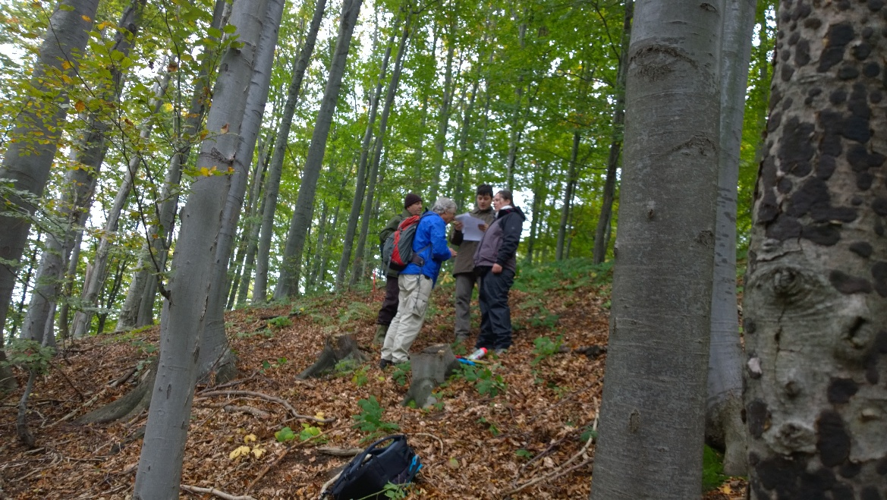
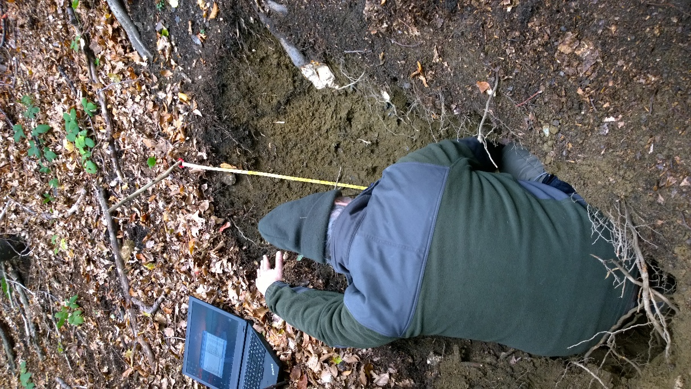

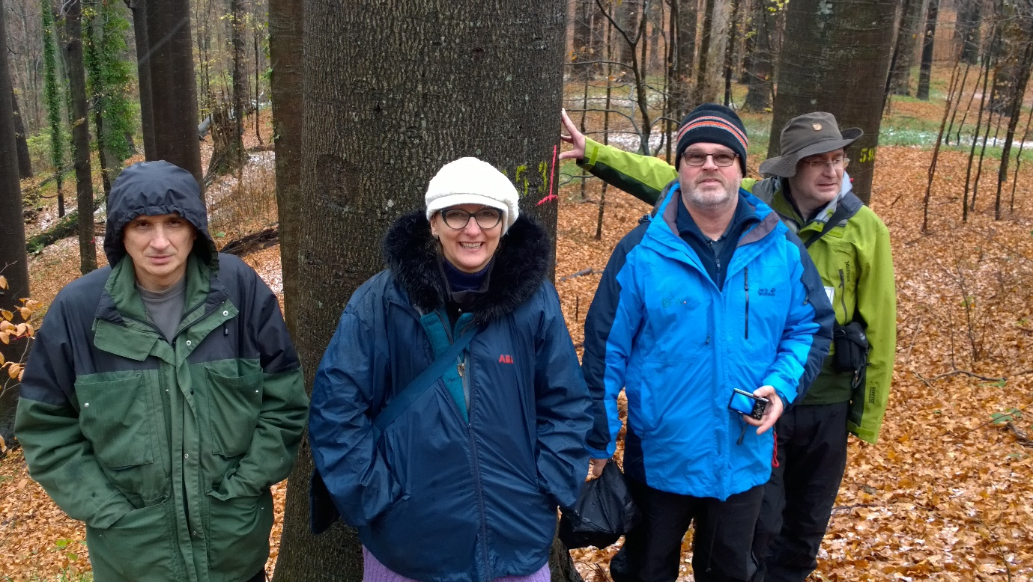
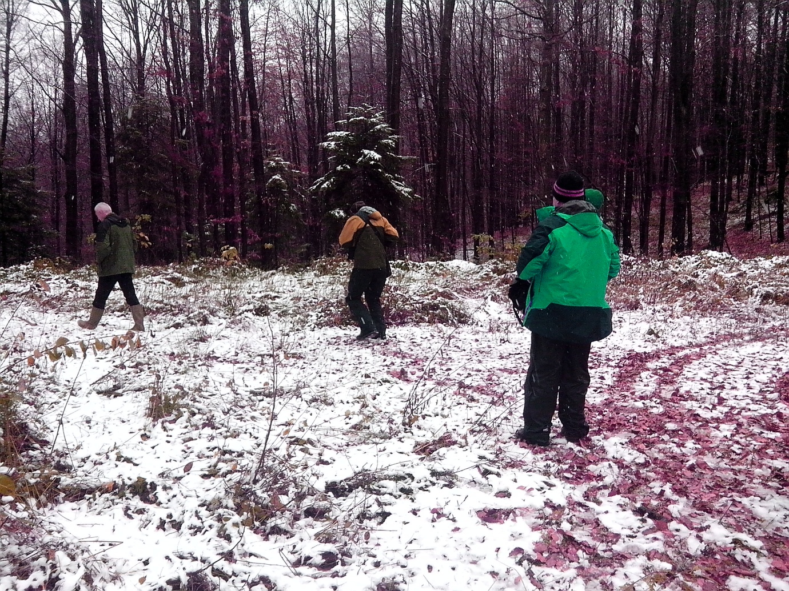
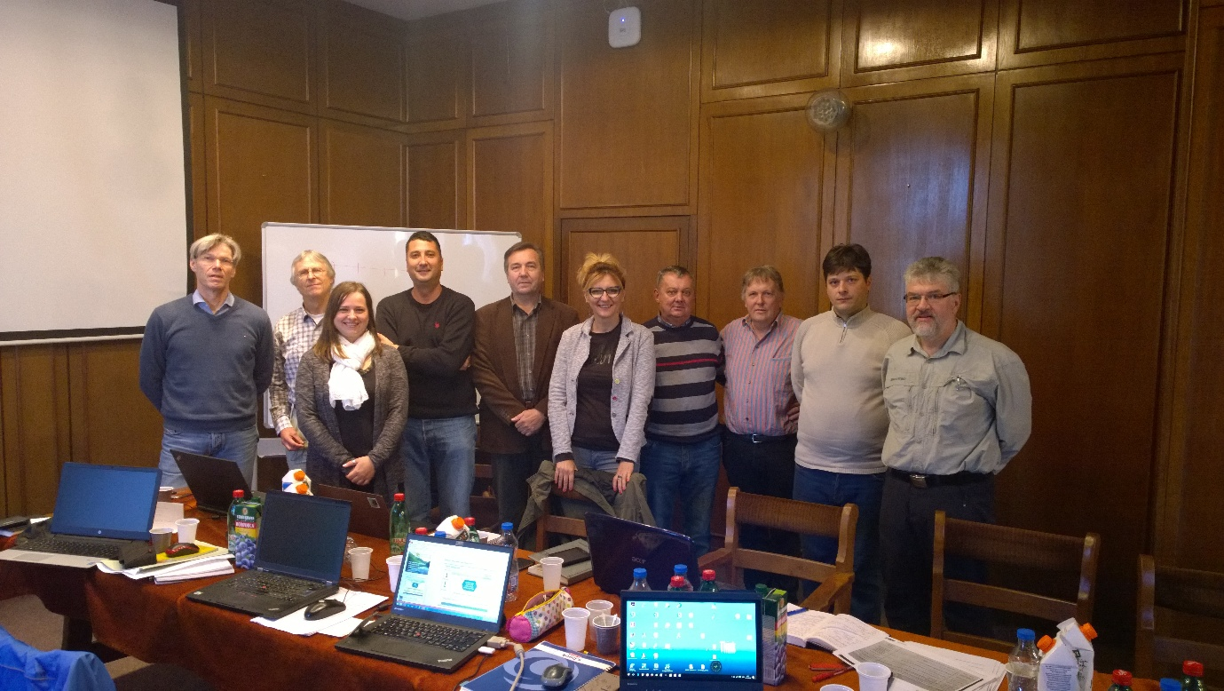

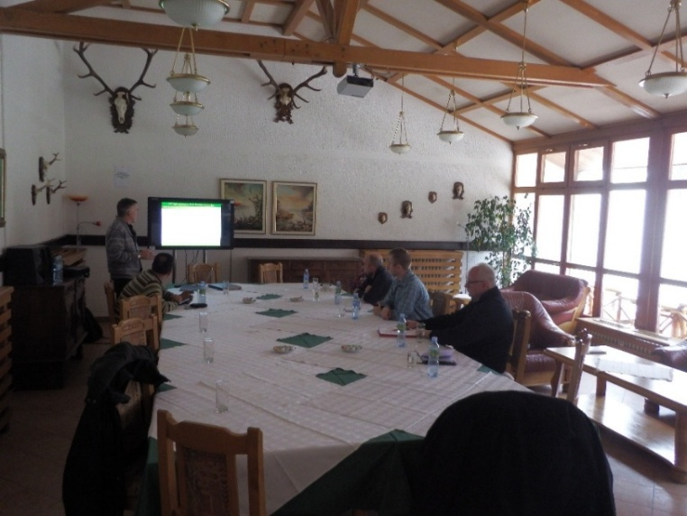
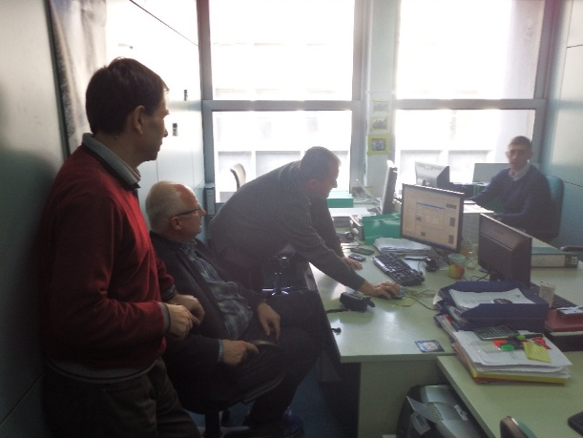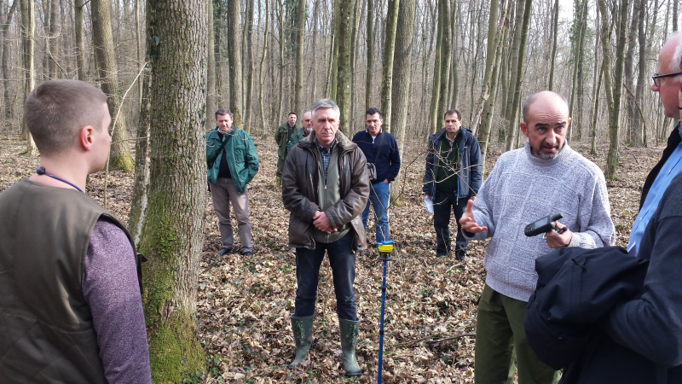
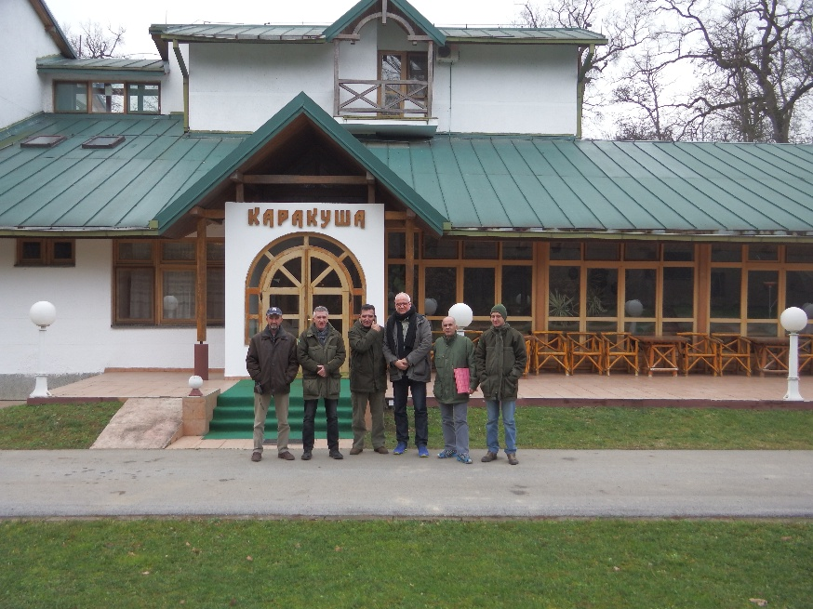

Поље унапређења 1: Пракса планирања газдовања шумама

Страни експерт: Dr Urlich Kohnle:

ИЗВЕШТАЈ:
Management types
1.1 Possible aspects to consider (general)
1.1.1 Terminology/naming of treatment phases (chpt. 4 “Intervention strategy)
Aspect.
Currently the terminology of the treatment phases is based on descriptive approaches which are – at least in part - driven by diameter structure expression: e.g. young pole phase, old pole phase). However, the major objective of the chapter is to describe appropriate treatment according to the growth dynamic phase of the respective stand which is much better classified along (site-specific) height growth dynamics rather than (density driven) diameter structure.
Suggestion.
Clarity for practitioners might benefit by adapting terminology of the phases more clearly to (height growth dynamic driven) treatment phases: e.g. “tending phase” instead of “thicket and/or young pole phase, “early thinning phase” instead of “old pole phase” etc.
As the last development phase (currently named “regeneration”) actually is a combination of harvesting mature trees and regenerating the stand, the name might be beneficially changed to “harvest & regeneration” in order to clearly distinguish it from the preceding treatment phase (“maturing phase”) aimed primarily at improving the quality of residual stand through removing poor quality, damaged, or diseased trees (“volume tending”) without the objective to regenerate the stand.
1.1.2 Merging of management types
It appears possible to merge the beech MT “even-structured” and “uneven structured” into one MT and treat “uneven structured” as an additional development phase.
1.1.2 Merging of treatment types/phases
In both MT (beech, oak) the treatment types/phases “sapling”, “thicket”, and “young pole” might be merged into one single phase (e.g. “tending”). Although these stages might be useful to differentiate structurally different development phases, the type of treatment does not really differ between these phases and therefore does not necessitate differentiation from the perspective of a forest practitioner.
1.1.3 Structure of describing treatments in treatment types/phases
Qualitative vs. quantitative description of treatment.
To improve the applicability of the guideline for forest practitioners, first priority when describing treatments should be a clear qualitative description of what is to be achieved by the treatment. This description should contain a clear visual description of the desired result after the treatment. Describing expected quantitative parameters of the treatment (e.g. volume to be cut, number of competitors to be removed, residual volume/basal) should be placed posterior and it should be made clear that achieving the qualitatively described result takes priority of fulfilling (exactly) the expected quantitative parameters.
Optimal vs. real development status of stands.
It is suggested that description of treatments provides for two alternatives:
a) Optimal development status
Treatment according to the status that is to be expected under the envisioned optimal production program. It appears not unplausibe, that such conditions might in the majority of cases probably be found mostly for the early development stages, when the respective stands have not been subject for prolonged periodes to “traditional” treatment differing from the envisioned optimal production program.
a) Sub-optimal development status
As older stands have usually been subjected for prolonged periodes to “traditional” treatment, their development status will most probably often differ from a status as envisioned under a “optimal” production program. It is therefore of major importance, that the guideline provides for clear alternative instructions how to proceed in such cases.
For example, in beech stands of the “older thinning phase” (25 – 30 m) that have not developed under a high-intensity high thinning regime (or even a target crop tree thinning regime) it is not advisable to start (belatedly) target crop tree selection and crop tree thinning. In such cases it appears better to prescribe a “free high thinning” regime (“freie Hochdurchforstung” according to Schädelin) as the alternative:
“In stands (of the older thinning phase; s.o.) which have not been subject to target crop tree thinning, thinning is conducted in the form of free high thinning without selection and permanent marking of future crop trees: release of dominant and co-dominant trees (Krafft classes 1 & 2) of good stem quality by removal of 1 – 2 competitors of poorer quality. Minimum distance between released trees should not be under 6 – 7 m).”
1.2 Notes on particular treatment descriptions
1.2.1 Beech
- merge development phases “sapling”, “thicket”, “young pole”
- introduce lower boundary of site productivity for application of crop tree thinning (Z-Baum-orientierte “Lichtwuchs-Durchforstung” according to Altherr); suggestion: not recommended for sites with site index <25m h_{dom} at age 100 yrs.)
- target diameter differentiated for quality:
currently, target diameter is obviously only defined for good quality trees. However, it might be benefitial – and helpful for practitioners – to also define a second target diameter applicable for the trees that do not reach the desired stem quality. As such trees of lower quality by definition reach maturity earlier at lower dbh, the corresponding target diameter should be set at at lower dbh (e.g. good/regular quality: 60cm+; poorer quality: 45-50cm).
- define “maturity” for stands in the “harvest & regeneration phase” by quantifying the percentage of stocking volume that has reached target diameter.
1.2.2 Oak
- merge development phases “sapling”, “thicket”, “young pole”
- adjust desired branch free bole length to 8 – 9 m &
lower boundary of early thinning phase to 18 m (dominant height)
- early thinning phase:
provide for (assumedly rare cases) when branch bole length of potential crop trees at 18m height is < 6m and therefore differing markedly from the desired objective:
“In cases where branch free bole length of the potential crop trees is <6m (low density stands with poor/slow self pruning) “qualify” the potential crop trees by pruning artificially to 6 m height prior to release.”
- Make sure that description of the (first) thinning in oak varies from that in beech. Whereas in beech for the first thinning immediate removal of all trees touching the crown of the PCT appears optimal, in oak only the more important competitors are to be removed (trees touching the crown of the PCT whose dbh and/or height exceed 70% of the respective PCT.

2. Demonstration/experiment plots
2.1 MT beech (Boranja)
2.1.1 Stand in early thinning phase
core program: two plots with 2 different treatments (Figure 1).
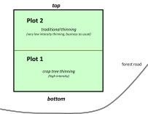 | Figure 1. Sketch map of the beech stand in early thinning phase.
Treatment 1: Crop-tree-thinning
- Begin of thinning:
when desired branch free bole length is reached
(e.g. branch free bole length of 8-10m is often reached at stand top height h₁₀₀ = 17-19m)
- Select (and mark) future crop trees
- Number of crop trees depending on the desired target diameter
target diameter (dbh) (max.) number of crop trees average distance
50 cm 110 / ha 10,0 m
60 cm 80 / ha 11,5 m
70 cm 60 / ha 13,5 m
80 cm 50 / ha 14,5 m
- Selection criteria for crop trees:
- growth vigor (only from Krafft classes I & II)
- quality
- distribution
(for beech growth vigor and quality are ranked of identical priority; distribution is ranked posterior)
- Release crop trees from all competitors: remove all trees around the crop tree whose crowns are touching the crop tree’s crown (laterally or from below)
no intervention in the areas between the crop trees
- Repeat thinning at height growth intervals of 3 m (approx. 2-3 thinnings per decade)
- Thinning intensity:
a) the first two thinnings are the most intensive, removing all trees from the crop tree’s
vicinity
b) lateron, thinning intensity subsequently declines (somewhat) by restricting removal to the
major competitors of the crop tree (trees with dbh >50% of the crop tree).
- Figure 2 indicates development of thinning intensity along the young development stages of beech stands under crop tree thinning regime.
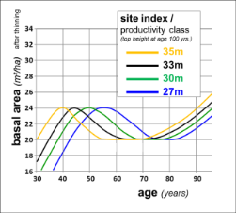 | Figure 2. Development of target basal area after thinning in beech crop tree thinning (according to Altherr). The different curves are calculated for different productivity classes (site indices) reaching from expected top height at age 100 years of 27 m to 35 m.

Treatment 2: Traditional thinning
Describe quantitatively a “very low intensity thinning” regime representative for the business as usual (current thinning regimes planned & applied in practice); e.g. “remove ca. 30 m³/ha per decade”

2.1.2 Stand in (latest thinning) maturing phase
core program: two plots with 2 different treatments (Figure 3).

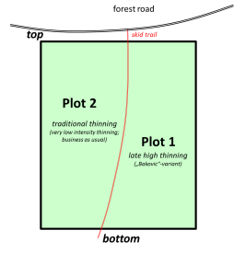 | Figure 3. Sketch map of the beech stand in late thinning phase.

Treatment 1: (Late) high thinning (“Bakovic”-variant; according to Schaedelin)
- Select (but do not mark) a good quality tree approx. every 7m (minimum distance 5m)
- Promote growth of the selected good quality tree by removing its major competitor
- Thinning intensity: 1 (-2) thinnings per decade
with max. removal of 80 m³/ha per thinning

Treatment 2: Traditional thinning
Describe quantitatively a “very low intensity thinning” regime representative for the business as usual.

2.1.3 Stand in harvest & regeneration phase
Two plots with two contrasting silviculture regimes (Figure 4).
As the stand is divided into two different development phases (uphill portions: canopy still closed; currently no generation; bottom portions: canopy opened up & already existing regeneration) the stand treatments are described in accordance with the respective development phase for two sub-plots (Figure 4). Due to the design including subplots with different development stages it would be helpful and important for future analysis, that stem coordinates of the current overstory trees are established when the experiment plots are set up.
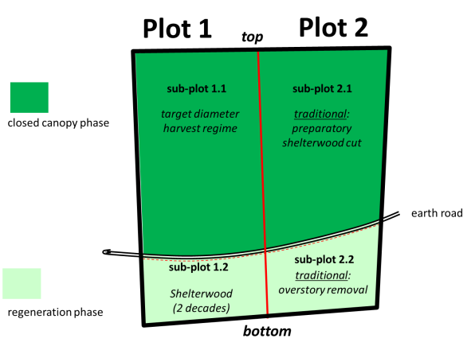 | Figure 4. Sketch map of the stand in harvest & regeneration phase.

Plot 1: Target diameter cutting
- Sub-plot 1.1 (latest thinning / maturity phase)
treatment: describe a target diameter cutting regime
- Define quality-differebtiated target diameters; e.g.
good (stem) quality: dbh 60cm
poor (stem) quality: dbh 45cm
- Cut all (and only) trees reaching (or exceeding) the preset target diameter;
after harvest remove all regeneration trees damaged by harvest (starting on sub-plot 1.2)
- In principle 1 intervention per decade
(possible exception: if volume to be cut exceeds 120 m³/ha; apply two cuttings per decade)
- Sub-plot 1.2 (regeneration phase)
treatment: shelterwood regime
- define removal of all overstory trees in a sheltwood regime within 2 decade
- after each cut remove all regeneration trees damaged by harvest
Plot 2: Traditional regime
Here, treatment description is to be clearly differentiated between the two sub-plots (Figure 2):
- Sub-plot 2.1 (latest thinning / maturity phase)
Describe quantitatively a preparatory shelterwood cut usually applied to such beech stands when reaching the regeneration phase.
- Sub-plot 2.2 (regeneration phase)
Completely remove residual overstory in the next cut
after the cut remove all regeneration trees damaged by harvest
2.2 MT oak (Sr. Mitrovica)
2.2.1 Stand in early thinning phase
core program: two plots with 2 different treatments; optimal plot size (0.5)-1 ha
Treatment 1: Crop-tree-thinning
- Begin of thinning:
when desired branch free bole length is reached
(e.g. branch free bole length of 8-10m is often reached at stand top height h₁₀₀ = 17-19m)
- Select (and mark) future crop trees
- Number of crop trees depending on the desired target diameter
target diameter (dbh) (max.) number of crop trees average distance
50 cm 130 / ha 9,0 m
60 cm 90 / ha 11,0 m
70 cm 70 / ha 12,5 m
80 cm 50 / ha 14,5 m
- Selection criteria for crop trees:
- growth vigour (only from Krafft classes I & II)
- quality
- distribution
(for oak growth vigour and quality are ranked of identical priority; distribution is ranked posterior)
- Note:
In order to gather relevant information on potential target oriented silviculture in hornbeam, I would find it most important to select and treat some good-quality hornbeam trees along with oak as future crop trees (e.g. ca. 10% of the selected crop trees might be hornbeam)
- Release crop trees from all competitors: remove all trees around the crop tree whose crowns are touching the crop tree’s crown (laterally or from below)
no intervention in the areas between the crop trees
- Repeat thinning at height growth intervals of 3 m (approx. 2-3 thinnings per decade)
- Thinning intensity:
a) in oak, thinning intensity is kept constant removing every time all neighboring trees
interfering with the oak crop tree’s crown (laterally or from below)
b) around hornbeam crop trees thinning intensity might be reduced after the first two
thinnings by subsequently switching to remove only lateral competitors.

Treatment 2: Traditional thinning
Describe quantitatively a “very low intensity thinning” regime representative for the business as usual.

2.2.2 Stand in harvest & regeneration phase
three plots with 3 different regeneration speeds / gap sizes (Figure 5).
Treatment 1: traditional rapid shelterwood cut regime
- Plot size ca. 4.5 ha; uniform treatment of whole block
- Duration of regeneration cutting: 10 (-15) years
- First (preparatory cut):
- reduce overstory to 2/3 of initial stocking volume
- plus complete removal of understory (and hornbeam)
- Second cut after 5 (-7) years:
- reduce overstory to 1/3 of initial stocking volume
- seeding if larger patches are without oak regeneration
- Third cut after 10 (-15) years:
- complete removal of remaining overstory

Treatment 2: medium rapid regeneration with medium sized shelterwood cuts
- Plot size ca. 4.5 ha; divided into 6 sup-plots à 0.75 ha
- Duration of regeneration period 20 (- 30) years
- Treatment of each sub-plot by three cuttings within 10 years (according to treatment 1)
- At installation of experiment:
- start regeneration cutting on 2 subplots
- low intensity thinning on the remaining area with overstory
- After 5 years:
- start regeneration cutting on the next 2 subplots
- low intensity thinning on the remaining area with overstory
- After 10 years:
- start regeneration cutting on the last 2 subplots

Treatment 3: slow regeneration with small gaps (“Femelschlag”)
- Plot size ca. 2.7 ha; divided into 9 sup-plots à 0.3 ha
- Duration of regeneration period 30 – 40 years
- At installation of experiment:
- cut overstory completely from 1 gap (0.3 ha)
- low intensity thinning on the remaining area with overstory
- After every 5 years:
- cut 1 additional gap (0.3 ha)
- low intensity thinning on the remaining area with overstory

Treatment 1  traditional rapid shelterwood regeneration within 1 decade  (plot size 4.5 ha) | Treatment 2  regeneration within 2 decades by medium sized shelterwood cuts à 0.75 ha  (plot size 4.5 ha) | Treatment 3  regeneration within 4 decades by small gaps à 0.3 ha [“Femelschlag”]  (plot size 2.7 ha)
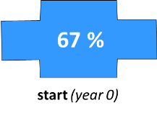 | 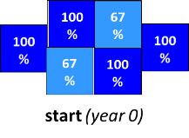 | 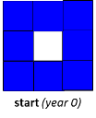
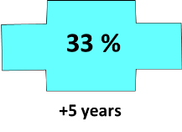 | 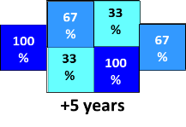 | 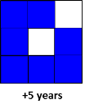
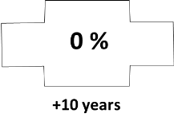 | 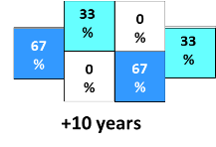 | 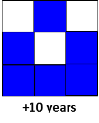
 | 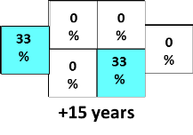 | 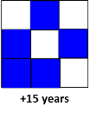
 | 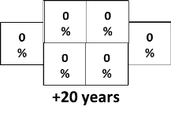 | 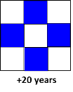
 |  | 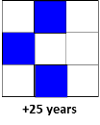
 |  | 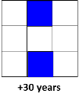
 |  | 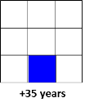
 |  | 
Figure 5. Sequences of overstory removal in the oak regeneration demonstration/experiment plot;

2.2.1 Stand in tending phase
Development phase:
install experiment right after completing regeneration (after removal of the residual overstory)
Principal experiment design:
3 tending treatments; suggested arrangement: latin square design with 9 plots (à 0.25 ha; Figure 6).
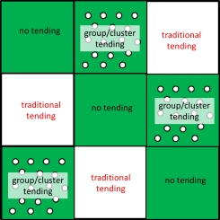 | Figure 6. Sketch map of tending experiment (3 treatments in a latin square design).

Treatment 1: no tending (control)
- untreated regeneration (no control of hornbeam, no fungizide etc.)
- goal: demonstration of principal requirement of oak promotion through intensive tending
Treatment 2: group/cluster tending
- tending restricted to groups/clusters of oak regeneration
do not treat area between the groups/clusters
- 100 groups/clusters per ha (radius 2.0-2.5m)
- release all oaks within a cluster by regularly removing/treating all oak competitors
- protect oak in clusters from mildew
Treatment 3: traditional tending
- release oaks on whole area by regularly removing/treating all competitors
- protect oak on whole area from mildew

2.2 Setting up demonstration/experiment plots
(general aspects)
Possible working schedule:
- select plots & mark boundaries in the field
- mark trees to be removed in the next cut, and – if applicable – the selected future crop trees
- establish/survey plot boundaries
- number trees in the field individually, mark dbh-measurement points (“measurement cross”), and measure dbh to the closest mm (either by 2 rectangular caliper measurements, or by circumference tape)
register species, dbh, and status of the respective tree (e.g. to be removed, future crop tree, etc.)
- for small trees (e.g. dbh<7cm), individual numbering might be skipped for reasons of workload; nevertheless, if measured (e.g. in dbh-groups of 1cm), the deb-measurement points should be painted on the measured trees
- height measurement:
- select ca. 30 trees (with intact crowns) per plot and tree species across the dbh-range of the plot
- measure height (bottom to top of crown), - and height of the first living (primary) branch at the tem (as an indicator for the crown’s base)
- regeneration:
regeneration can usually not be measured on the whole plot but needs to be assessed by measuring (evenly distributed) sample plots
- plots with included sub-plots:
here establishment of stem coordinates (trees with dbh >7cm) appears advisable plots with quality-differentiated target diameters:
assess stem timber quality of each stem for e.g. the lower 5m portion of the stem; e.g.
- good timber quality (A: potential veneer of good quality saw timber)
- inferior timber quality (B: no potential for good quality saw timber)

ИЗВЕШТАЈ:
Поље унапређења 2: Шумска станишта и воде


Soilution GbR. Steinrücken - Behrens
Illinger Str. 115, 66265 Heusweiler
Standorte:
Dr. Ulrich Steinrücken
Illinger Straße 115
66265 Heusweiler
Tel: 06806 603542
ulrich.steinruecken@soilution.de

Dr. Thorsten Behrens
Heiligegeiststr. 13
06484 Quedlinburg
Tel: 03946 8190863
thorsten.behrens@soilution.de

Heusweiler, den 25.11.2017

Water balance level
Short manual

0 Note
1 Steps to get water balance level
2 Available water capacity (AWC) and soil and water balance level (WBL)
3 Landscape main factors
3.1 Position in relief and surface outforming (implementation)
3.2 Inclination
3.3 Landscape main factors in combination
4 Climate site factors
5 Combination

0 Note
This is a blue print. We transfer knowledge from Germany, but this must be prooved in your country. The first time it seems to work, but we need a solid data base to make a resilient and helpfull application. Send us your data. We will collect them and correct false estimations.

Attached you can find an Excel-file named "WBL_Serbia". Inside you find the following sheets:
WBL_all_cal | calculation matrix:to use, if one wants to adept the WBL
WBL_all_tab | WBL-table
WBL_all_tab_text | WBL-table to put into text
Legend | Legend with explanations

Use the calculationtable, if you have serious results to adept the WBL. If you change the numbers in the columns "addend", the corresponding WBL will change automatically.

1 Steps to get water balance level

A) Calculate available water capacity for each horizont of a soil profile, using horizont magnitude, texture, content of coarse fraction, density of soil. To describe the parameters use a profile hole, which is more than 80 cm deep. Sometimes it is necassary to include the humus layers.
B) Use the following table to classify AWC

Tab.1: Classification of AWC
AWC_Class | AWC [mm] 0 - 80cm
1 | 0 - 10
2 | >10 - 25
3 | >25 - 45
4 | >45 - 65
5 | >65 - 95
6 | >95 - 130
7 | >130
C) Check rainfall in vegetation period (summer). Select the convenient determination table.
D) Use informations about
- position in relief
- outforming (implementation) of surface
- inclination
- total insulation
to determine water balance level.
E) Check vegetation parameters to control the water balance level. Adept WBL if needed.

2 AWC and WBL
If you have periods of dryness in the vegetation time, the AWC of the soil is one of the important parameters in limiting the health, survey and crop of plants. This water storage must be fulfilled in winter time.
Between AWC and landscape there are several relationhips, which has to be cosidered: When it is raining, water drops are falling to the surface and infiltrate. Some of the water will fullfill the storage in soil, some will pass through small or big pipes following the gravity. This does also happens when snow smelts.
So beside the soil properties like texture etc. the position in relief, the outforming of the surface and the inclination have effects on waterflow in the soil (interflow). If the inclination is not to high, the water will move slowly and the soils along the interflow pathes will get slightly wet. This in periods of dryness additional water can be used by plants, but is not accounted for the calculation of AWC.
Also micro-climatic conditions have effects on the evapotranspiration (ETP). Plants in northern expositions have lower ETP then the same species in southern exposition. Even if you find the same AWC, the soil in the southern exposition will get dry earlier than in the north. And you have effects on the crop, naturally.
So comparing AWC and WBL we have on the one hand the AWC, which shows a dimension of the the water storage in the soil usable by plants at the beginning of the vegetation time. On the other hand you have the WBL, which contains the AWC and consideres the influence of important site parameters in the vegetation period.
3 Landscape main factors
3.1 Position in relief and surface outforming (implementation)
The position in relief is an important parameter to describe the influence of additional water. Soilution is using a mathemetical model to analyze landscapes which bases on the work of Yokohama et al. (2002) and Stepinski & Jasiewicz (2011). Within the model
- for every point/pixel in an elevation model
- in every direction
- in a defined neighborhood
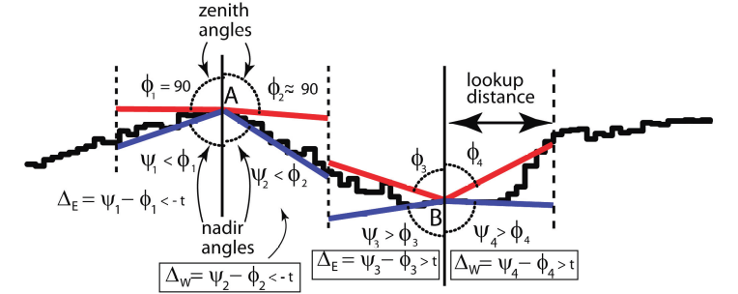
the ankles to the farest highest and lowest point (zenith and nadir angles) were searched (Fig. 1).

Fig. 1: from Stepinski und Jasiewicz (2011)

Using the calculated ankles defined "geomorphon" were build.

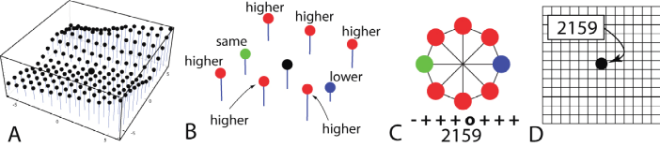

Fig. 2: from Stepinski und Jasiewicz (2011)

The geomorphons can be aggregated to the following landscape units:
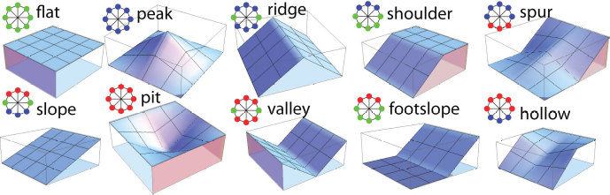

Fig. 3: from Stepinski und Jasiewicz (2011)

Relief position and outforming shows effects to the potential of additional water. 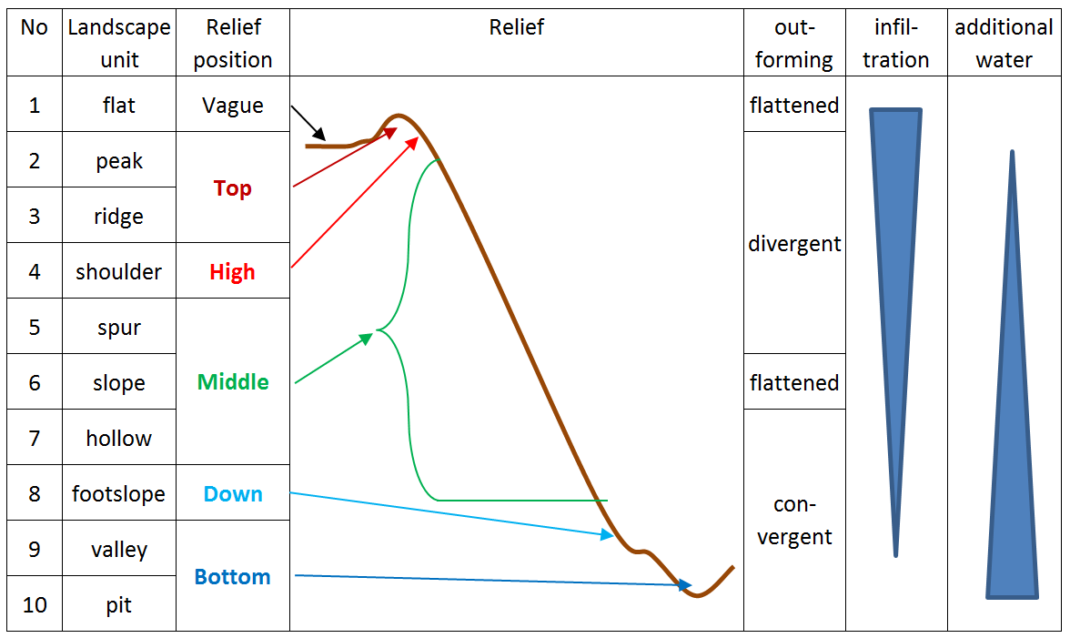
Fig. 4: Landscape units, surface outforming and the potential of additional water

3.2 Inclination
Also inclination has an influence to the water supply. The steeper a slope, the faster interflow and runoff is running. This may have a negative effect to the additional water on a site.

3.3 Landscape main factors in combination
In combination of the main landscape factors position in relief, surface outforming and inclination one can estimate the influence on the water supply. Tab. 2 shows the potential of additional water depending on the landscape units and inclination in a scala from "--" (less additional water) to "++" (more additional water).

Tab. 2: Assessment of the combination landscape unit and inclination facing additional water
Landscape unit | Gently inclined | Steep
(2) Peak | - - | - -
(3) Ridge | - - | - -
(4) Shoulder | - - | - -
(5) Spur | - | -
(6) Slope | 0 | 0
(7) Hollow | + | 0
(8) Footslope | ++ | +
(9) Valley | ++ | ++
(10) Pit | ++ | ++

For practical use, the combination of landscape units and inclination were aggregated in 10 classes. To differ between steep and not steep is used 30° as a mark.
Tab. 3: Aggregation of the landscape units with different slopes
 | code
Landscape unit | Gently inclined | Steep (> 30°)
(2) Peak | 200 | 200
(3) Ridge | 300 | 300
(4) Shoulder | 400 | 400
(5) Spur | 560 | 564
(6) Slope | 560 | 564
(7) Hollow | 700 | 704
(8) Footslope | 800 | 804
(9) Valley | 900 | 900
(10) Pit | 900 | 900

4 Climate site factors
Beside the longiness of a duration period in the vegetation period and the quantity of rainfall micro-climate conditions are very important to the assess of water supply. Especially the evapotranspiration (EVT) must be considered. One simple indicator for EVT is the exposition. On sites with southern exposition the same AWC will be exhausted earlier than on a site with northern exposition.
Tab. 4: Classes of total insolation
class | explanation
sun | sunny
mid | middle
sha | shadowy

5 Assessment of water balance level
The scale of the water balance level is spread up from 1 (extrem dry) to 9 (extrem fresh). Sites, classified with WBL 1 are often cliffs and rocks with a very thin rootable zone, with roots in fissures of the bedrock. On the other hand are sites with WBL 9 typically deep soils with a less content of stones an a deep rootable zone, sometimes lightly hydromorpus in deeper horizons of the profile.
To assess a site, it is necessary, to value not only the point with the profile, but the area the profile is typical for. The calculation of the AWC in the profile has to be adapted, if there are blocks and big stones covering the surface of the area, but are not equivalent in the profile hole.
The WBL-tables are structured by the quantity of rainfall in the vegetation period (RRwarm). It is also possible to use the climatic water bilance (CWB), but soilution has no experience in using CWB.
The head of the tables above are structured like this:
Rainfall in vegetation period

AWC-class

total insolation
landscape unit (aggregated)
[in code and words]

To use the tables, you must know the quantity of rainfall in vegetation period. In GIS you have to union rainfall classes in vegetation period (300-450; 450 - 600; 600 - 750; > 750), the data of landscape units, inclination- and total insulation-classes in one map.

Tab. 5: Determination of WBL using several site characteristics
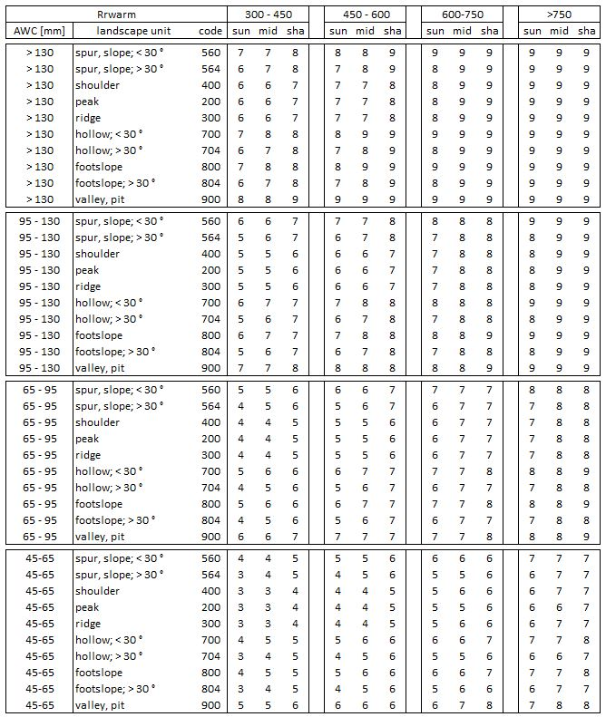

Tab. 5: Determination of WBL using several site characteristics - continuation
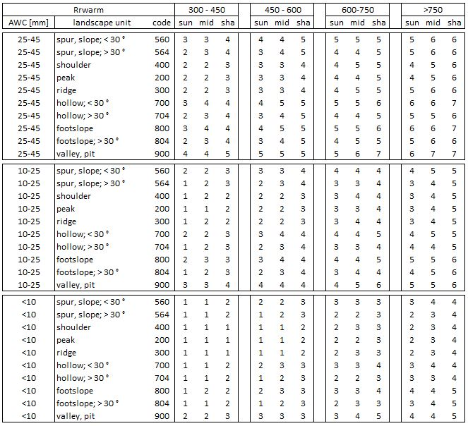

Поље унапређења 3: Инвентура шума

Страни експерт: Dr Matthias Dees:

ИЗВЕШТАЈ:

Short mission report:

Mission Duration: 2.12.2016 – 14.12.2016

Objective: follow‐up of issues from the main mission in the
course of the amendment)

Reference:

Project title: Entwicklung und Einführung einer innovativen Forstmanagementplanung
unter Berücksichtigung ökonomischer und ökologischer und sozialer Aspekte in Serbien -
Implementation of an innovative forest management planning considering
economic, ecological and social aspects in Serbia

Razvoj i uvođenje inovativnog koncepta planiranja gazdovanja šumama uz
poštovanje ekonomskih, ekoloških i socijalnih aspekata u Srbiji

Project‐N°: W‐SRB 15‐01

Document: Terms of Reference: International Short‐Term Assignment
‐ Adjustment of the inventory technique and information
management
‐ Including amendment of the contract (as confirmed 22.08.2016)

Contract amendment concluded between Unique and Matthias Dees on 10.10.2016

Prepared by Matthias Dees on 14. 12.2016 and finalised 09.01.2017:

Short 2 page report with an attached presentation.

Day 1- 12.12.2016

Meetings with Dragan Borota (DB), Nenad Petrović (NP) & Branko Stajić (BS)

‐ Identification of task, scheduling of meetings
‐ Status assessment on the contract with AV

Software: Contractual text is prepared and translated, clarification of detailed level issues required,
meeting with AV scheduled for 13.12.2016, issues pre‐discussed.

Data access: Letter requested by the forest directorate was not used as such, but initiated a first exchange on Director level. Meeting with Predrag Jović (PJ) scheduled for 13.12.2016. Meeting with Saša Stamatović (SS) scheduled for 14.12.2016, this shall include presentation of the H2020 project DIABOLO, where both experts (national and international) are involved and that will be of relevance for damage mapping in Serbia

Day 2 - 13.12.2016

Meeting with DB DP and PJ

Issue of data access discussed, meeting on technical level with RGZ foreseen for January. MD brought issue of access to Sentinel 2 into the discussion. They will provide a good potential for rapid mapping of severe damages in forests from 2017 on and very good potential from 2018 on (when both Sentinel 2A and Sentinel 2B are available for monitoring in the Copernicus frame work free of charge and with Copernicus support for public users. It was suggested to explore in contact with RGZ how access to Copernicus data will be organized in Serbia for Serbian public authorities.

Internal meeting with DB, DP and further University team members on the DIABOLO project (but with relevance for BMEL project as mentioned above). Please be referred to the attached presentation.

Meeting with DB and NP on Software contract

Open issues have been resolved: (1) Addition of the item of a standard form sheet as designed by the FMP expert team (2) addition of H100 as a basic parameter for the stand description (3) agreement on the integration of adjusted attributes definitions as brought into the discussion by NP.

Day 3 14.12.2016

Meeting with SS and NP on forest monitoring issues

Presentation of the DIABOLO project that has relevance for forest disturbances monitoring, for capacity building at the forest faculty and that will provide examples of the potential of disturbance monitoring in Serbia using Sentinel 2 A and Sentinel 2B data.

The project idea was well acknowledged.

SS approved that the establishment of a co‐operation with RGZ to establish a direct contact to RGZ data is on its way and that a procedure how the Forest directorate could be involved jointly with the Directorate of Agriculture in the update of the landuse information (forest area, agricultural area) is under development.

Outlook on future project components with relevance for the topics addressed by the BMEL project as discussed during the stay

1‐ Advanced curriculum on Forest Inventory, Forest Monitoring, GIS and Remote Sensing (focus on Remote Sensing) for the forest faculty is an important issue to increase the capacity

2‐ Professional training for those units that will make more intensive use of remote sensing (e.g. the forest institute with focus on the use of drones)

3‐ Once DIABOLO provided encouraging disturbance mapping results the methodology should be considered for operational use after an assessment of the services provided by third parties (Joint research center of the EU in Ispra, Italy in charge of setting up Elements of a European system for the monitoring of forests; RGZ, Serbia for support of public entities in Serbia with interest on environmental monitoring, etc.).

’’GREENFOR‘‘

У оквиру планираних основних активности у Пројекту, као активност 9 планирано је следеће: ’’Развој ''динамичне'' базе података о различитим елементима састојинског стања, дорада софтвера ОСНОВА ЕВИД итд.’’
Имајући у виду претходно, у оквиру реализације Пројекта било је, како је то планирано потписаним Анексом Уговора између Министарства пољопривреде и заштите животне средине – Управе за шуме и Шумарског факултета, потписаног 21.03. 2017. године, под бројем 01-840/3, '' … неопходно дорадити - унапредити софтвер и базу података за газдовање шумама у складу са спецификацијом нових функционалности за потребе реализације дела наведеног пројекта, кроз поступак јавне набавке који ће спровести Корисник средстава…''. За обављени посао, Шумарски факултет треба исплатити 860 996, 00 динара, како је то предвиђено Пројектним предлогом и Уговором.
Руководилац Пројекта, Др Бранко Стајић, дана 11.04.2017. године, поднео је Захтев Управи факултета да се покрене Јавна набавка услуга Дораде и унапређења софтвера и базе података за газдовање шумама у складу са спецификацијом нових функционалности. Средства за финансирање ових активности на Пројекту обезбеђена су Уплатом од стране Управе за шуме, на основу поменутог Уговора и Анекса и према планираној динамици реализације Пројекта у току 2017. године Потребна средства износе 635 242,84 РСД без ПДВ-а и 225 753,16 РСД ПДВ, што укупно износи 860 996 РСД.
Декан Шумарског факултета је, дана 18.04.2017. године, донео одлуку о покретању поступка Јавне набавке мале вредности. Отварање понуда извршено је дана 05.05.2017. године, након истека рока за понуде понуђача.
На конкурс се јавила једна фирма, ГРЕЕНФОР, кога заступа Александар Васиљевић. Данља 09.05. 2017. године донета је Одлука о додели уговора Агенцији за консалтинг ГРЕЕНФОР, према цени из понуде.
Након тога, дана 15.05. 2017. године потписан је Уговор са датом фирмом за пружање напред наведених услуга.
ГРЕЕНФОР је, сходно переузетим обавезама, доставио све тражене услуге и предочио у форми Извештаја, који се у наредном делу Извештаја по завршеном Пројекту, заједно са свим осталим претходно наведеним документима, ставља на Увид Комисији.

Izveštaj
o realizaciji ugovora 01-1786/2
koji se odnosi na
»Implementacija inovativnog planiranja gazdovanja šumama uz poštovanje ekonomskih, ekoloških i socijalnih aspekata u Srbiji«

Beograd, 27.06.2017

Visoki prioritet zahteva za unpaređenje softvera definisan od strane projektne radne grupe i terenskih timova.

- OBUKA, dan upoznavanja sa novom verzijom OSNOVA-ePGŠ timovi
Sprovedena je jednodnevna obuka na šumarskom fakultetu za članove radnog tima BMEL projekta.
- Godina seče
Zahtev: Novo definisanje karakteristika na nivou Sastojine:
Olakšati standardne opcije analize za atribute na nivou sastojine.
Pripremiti unos podataka na terenu ili u kancelariji, obezbediti informacije o godini seče u prethodno planiranom periodu automatski.
Naziv karakteristike: Godina seče.
Kodiranje godine: godina 1 …10 planskog perioda.
Korišćenje: razbijeno po godinama , podrška planiranju na godišnjem nivou.

U planu seča dodata je godina planirane realizacije seče. Godina se unosi u opsegu od 1-10 i prestavlja relativnu godinu realizacije u odnosu na I godinu važenja osnove.

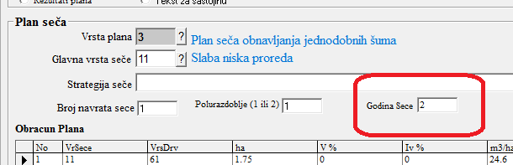

Ovaj podatak se može koristi kao atribut za izradu rekapitulacija.

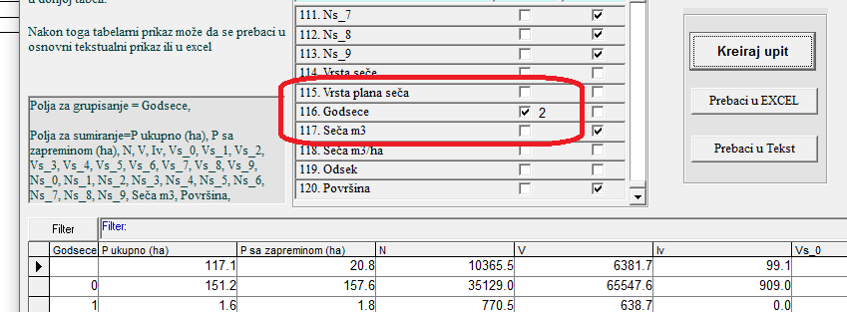
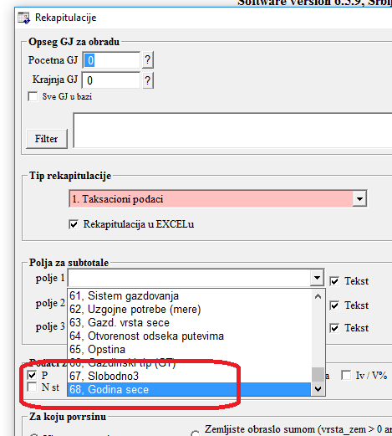

Godina seče se takodje prikazuje kod pregleda plana seča svaki pojedinačni odsek.

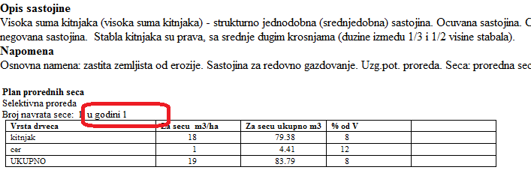
- Grupe Gazdinskih klasa (GGK)
Zahtev: Novo definisanje karakteristika na nivou Sastojine: (Videti listu šifri u SIFRE centralne DB Uprave za šume.
Olakšati standardne opcije analize za atribute na nivou sastojine.
Ugraditi automatski vezu između GGK i Gazdinskih Klasa u SIFRE i kao funkciju da reklasifikuje sastojine po GGK automatski.

Grupe gazdinskih klasa se formiraju automatski na osnovu unete sastojinske celine.
Ovakav način formiranja GGK je predložen od strane projektnog tim.
Prvobitini predlog, da se GGK automatski formiraju na osnovu na osnovu unete gazdinske klase nije moguće iz razloga što gazdinska klasa ne predstavlja jedinstven atribut već se formira kao kombinacija 3 atributa (osnovna namena + sastojinska celina + ceno ekološla jedinica, odnosno osnovna namena + sastojinska celina + tip šume).

Opcija za farmiranje GGK se nalazi u meniju obrada podataka/BMEL projekat

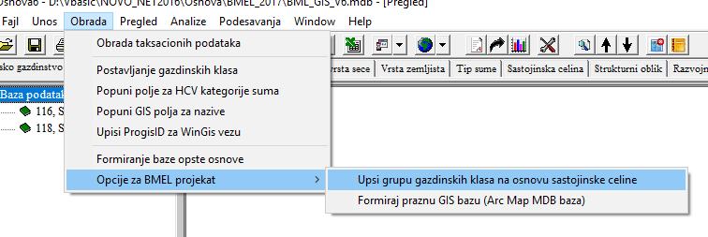

Šif za GGK se nalaze u šifrarniku u poglavlju 32100

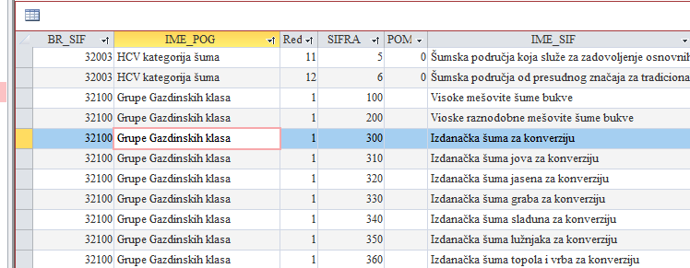

U šifrarniku (sifreSR.mdb, Verzija: 10.2 i novija), u tabeli “transformacija” uspostavljene su veze izmedju sastojinske celine i GGK na osnovu kojih se vrši automatsko upisivanje GGK.

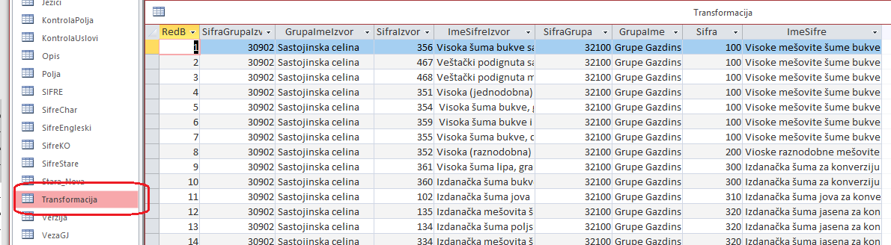

Atribut GGK je aktivan u unosu podataka, kao i u rekapitulacijama za atribute sastojine.
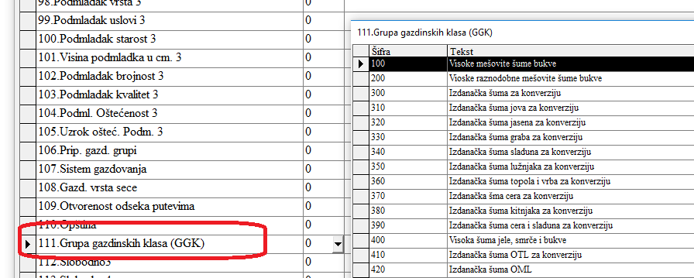

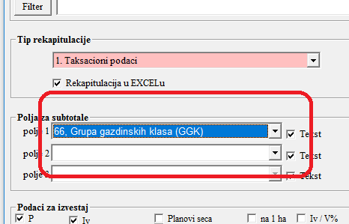

- Uzgojne faze/grupe
Uzgojna grupa je dodata za nivo odseka, kao i za nivo primerne površine (kruga).

Šifrarniku su dodate sledeće šifre:

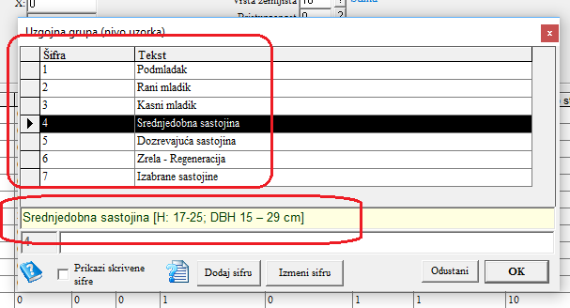
S obzirom da je tekst šifre koji je predložen od strane radne grupe bio poreviše dugačak, šifra je skraćena, stim što je kod izbora šifre, u delu za napomene, prikazano detaljno objašnjenje šifre.

Ovaj atribut za nivo sastojine nosi naziv Uzgojna grupa (nivo sastojine)

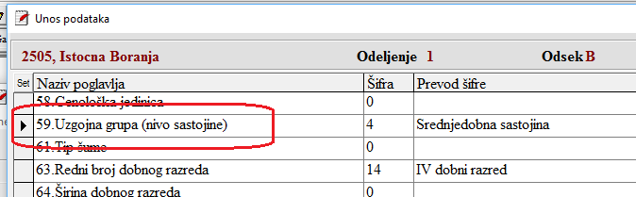

Na nivou uzorka, naziv atributa je Uzgojna grupa (nivo uzorka)
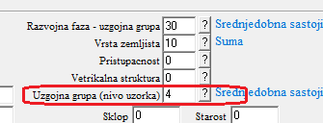

Kod unosa podatka za nivo uzorka (kod dodavanja novog uzorka), kao podrazumevana vrednost se upisuje ugrojna grupa koja je predhodno uneta za sastojinu.

Tokom obrade podataka program vrši kontrola unetih uzgojnih grupa. Vrši se upoređenje uzgojne grupe sastojine sa uzgojnim grupama koje su unete za primerne površine.
Program prijavljuje eventulane nelogičnosti, kao na sledećem primeru

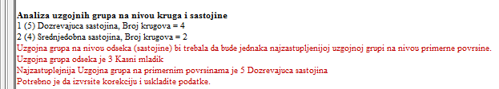

Kod izveštaja u RTF formatu koji se pozivaju sa F2, dodate su nove opcije (izveštaji) za nivo odseka:
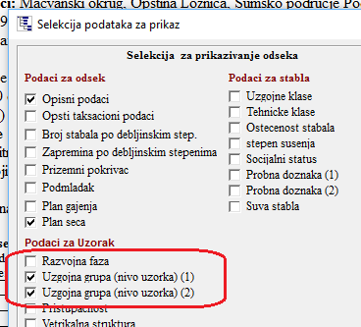

Selekcijom izveštaja za uzgojnu grupu dobija se sledeći izveštaj:

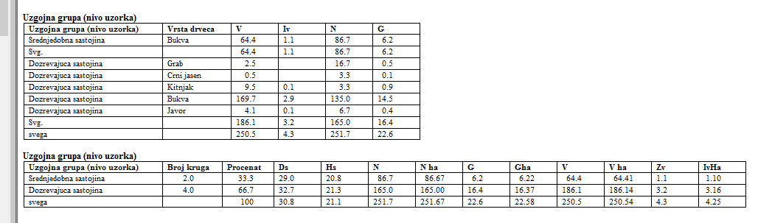

Takodje, kod rekapitulacija, svakom od opisnih atributa koji se odnose na sastojinu, može se dodati podatak za grupisanje uzgojnih grupa:

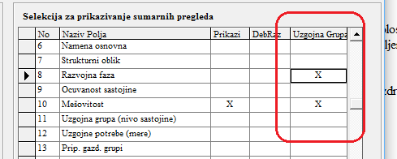

Na ovaj način se dobijaju sledeći izveštaji:
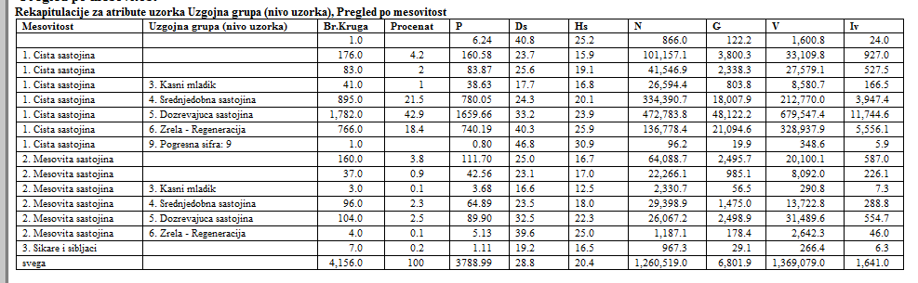

Kod rekapitulacija po izboru polja, ugrađena je posebna opcija za rekapitulacije koje sadrže atribute sa uzoraka (krugova, primernih površina).
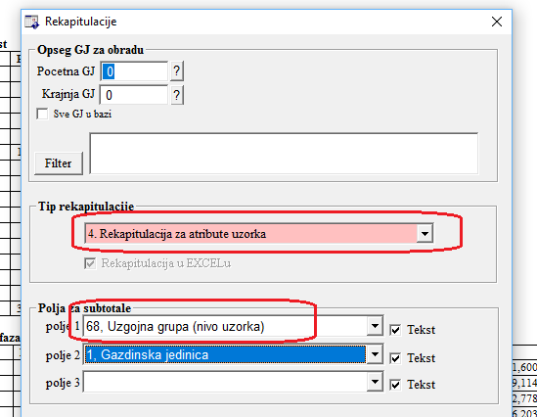

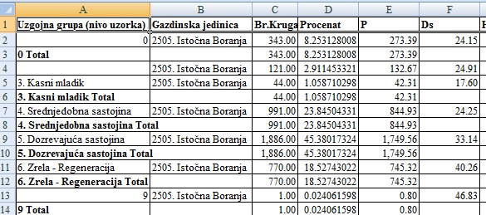

- Socijalna klasa
Zahtev: Novo definisanje na nivou stabla
BR_SIF | IME_POG | SIFRA | IME_SIF | IME_ENG
100200 | Socijalni status stabla | 1 | Predominantna I dominantna (KRAFT 1 I 2 uključujući I stabla na osami) | Very dominant and dominant (KRAFT 1 and 2 including a secluded tree)
100200 | Socijalni status stabla | 2 | Kodominantna (KRAFT 3) | Codominant (KRAFT 3)
100200 | Socijalni status stabla | 3 | Potištena uključujući i suva stabla (KRAFT 4 i 5) | Cupressed including dead trees (KRAFT 4 and 5)

Ovaj atribut se odnosi na premereno stablo. Atribut je dodat u opciju za unos stabala.

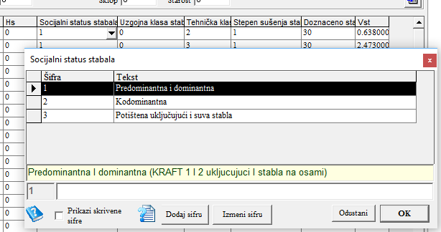

Za ovaj atribut je moguće izraditi potrebne rekapitulacije
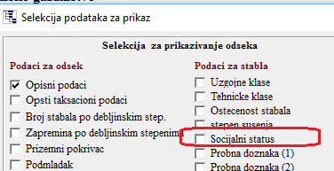

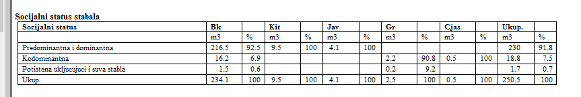

- Tehnička klasa
Zahtev: Novo definisanje na nivou stabla: (Videti listu šifri u sledećem poglavlju)

Opcije su dodate identično socijalnoj klasi stabala.
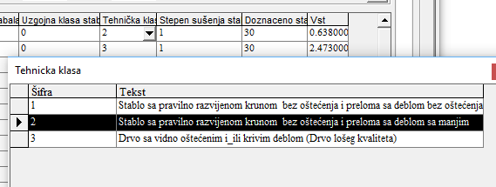

BR_SIF | IME_POG | SIFRA | IME_SIF | IME_ENG
100500 | Tehnicka klasa stabla | 1 | Stablo sa pravilno razvijenom krunom bez oštećenja i preloma sa deblom bez oštećenja | Tree with a properly developed crown without damage and fracture
100500 | Tehnicka klasa stabla | 2 | Stablo sa pravilno razvijenom krunom bez oštećenja i preloma sa deblom sa manjim oštećenjem oštećenja i malo kriva | Tree with a properly developed crown without damages and fractures with minor damage damage
100500 | Tehnicka klasa stabla | 3 | Drvo sa vidno oštećenim i_ili krivim deblom (Drvo lošeg kvaliteta) | Tree with a trunk with visible damage and curved

- Probna doznaka
Zahtev: Novo definisanje krakteristika na nivou stabla: (Videti listu šifri u sledećem poglavlju);
Olakšati standardne opcije analize za atribute na nivou stabla;
Pripremiti analizu za grupisanje atributa:
1,4,5 – planirano za seču,
2,3 planirano da ostane;
Olakšati analizu za vrste drveta i probnu doznaku u dvosmernoj tabeli;
Pripremiti pristup za specijalni grupni izveštaj & analizu;
Šifre moraju biti izmenjene;

Za potrebe probne doznake, izvršeno je proširenje šifrarnika sa odgovarajućim atributima. Šifre za probnu doznaku su sledeće:

BR_SIF | SIFRA | IME_SIF | SKR_IME | IME_ENG | SKR_ENG
100700 | 0 | Bez statusa | 0 | No status | 0
100700 | 10 | Potencijalno Stablo Budućnosti | PSb | Potential crop tree | PCT
100700 | 21 | Konkurent stablima budućnosti | Konk | Competitor | Comp
100700 | 30 | Indiferentno, bez uticaja stablo | Ind | Indifferent | Inter
100700 | 41 | Hitno za seču, vrlo lošeg kvaliteta | Za seču | Urgently for cut - Very poor quality | For cut
100700 | 51 | Zrelo, seča obnavljanja | Zrelo | Final - Recovery cut | Final

Poslednja cifra u šifri za probnu doznaku ukazuju da li se stablo seče ili ostaje u sastojini, na sledeći način:
100701 | 0 | Ostaje u sastojini |  | Remain in stand
100701 | 1 | Za seču |  | For cutting

Kod izveštaja (F2) za probnu doznaku, omogućena su 2 tipa izveštaja:
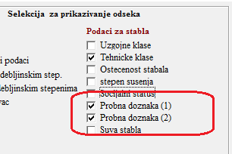

Izveštaji u I grupi sadrži sledeće elemente:
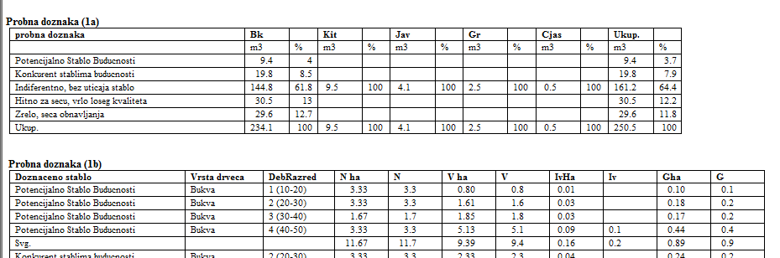

Druga grupa izveštaja sadrži 3 prikaza :
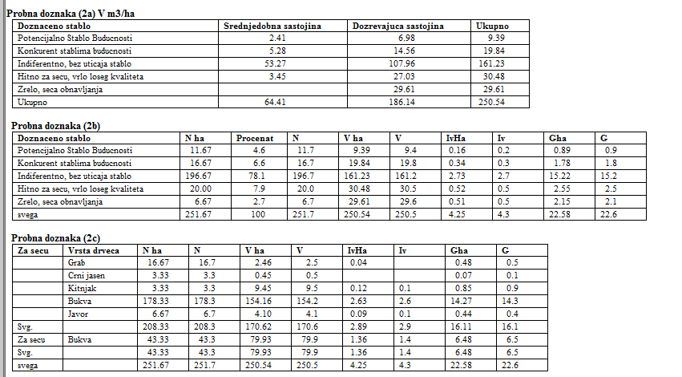

- Usavršeni izveštaji
Zahtev: Dodati standardnom izveštaju:
G, G/ha, HD, Dg; Hg
Do: DBH dominantnih stabala (gornja visina po WEISE)
Ho: Bisina dominantnih stabala (gornja visina po WEISE)

Zahtevane informacije u dodate u bazu podataka kao nova polja. Isti se upisuju tokom obrade taksacionih podataka.

Obrada visina za 20% najdebljih stabala se računa na osnovu njihovog srednjeg prečnika. Srednji prečnik za 20% dominantnih stabala se računa preko njihove temeljnice. Na osnovu srednjeg prečnika, visina se dobija iz visinske krive, za svaku pojedinačnu vrstu drveta iz odseka.

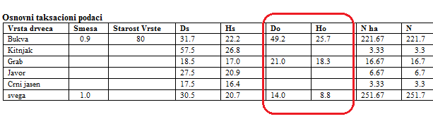
U svim izveštajima i rekapitulacijama dodata je temeljnica G, pored podataka N, V i Zv

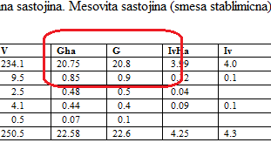

- Opcija za unos teksta u plan seča pri izradi plana
Zahtev: Opcija unosa teksta u koji opisuje vrstu seče i gazdinski tretman da bude dostupan za unos na nivou tabele za plan seča za svaki odsek

Kod unosa plana seča dodata je opcija za unos tekstualnog dela, odnosno strategije seče:

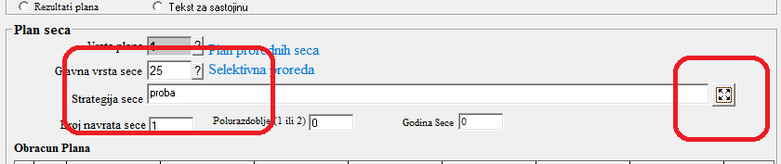

Polje za unos se može proširiti, u koliko je tekst koji se unosi veći.
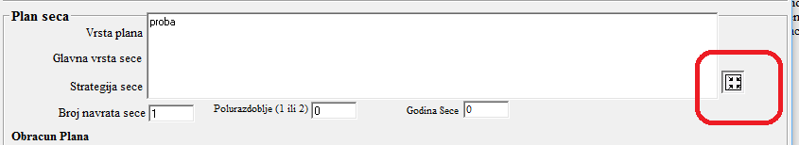

Tekst koji je unet u planu seča, ispisuje se u pregledu odseka ispod plana seča.
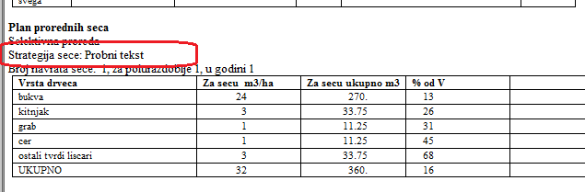

- Novi na jednoj strani standardni izveštaj za svaku sastojinu
Korisnik je u mogućnosti da samostalno definiše sadržaj podataka za odsek. Ovaj prikaz može da sadrži stanje, plan i evidencija izvršenih radova na jednoj strani za svaki odsek

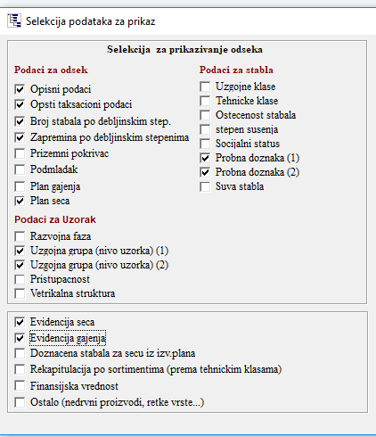

- Proširenje na sve vrste drveća
Zahtev: Omogućavanje posebne analize za vrste (više od 6 vrsti)
Korišćenje postojećeg grupisanja vrsta drveća za standardne analize

za razliku od ranijih verzija programa, kod kojih je broj vrsti drveća u odseku bio ograničen na 6, u sadašnjoj verziji broj vrsti drveća u odseku nije ograničen.

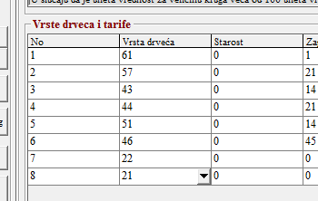

Izveštaji koji sadrže vrsu drveća obuhvataju sve unete vrste, bez obzira na njihov broj.
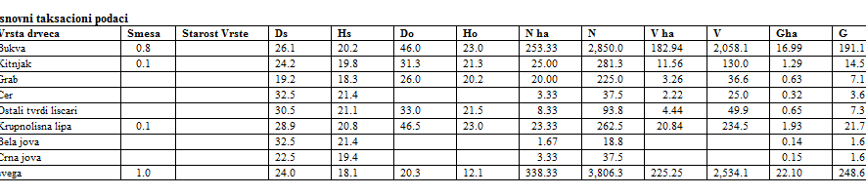

Vrste drveća mogu i da se grupišu, na osnovu definicije za grupisanje koja je zadata u šifrarniku. Za sada je grupisanje tako podešeno da se dobijaju pregledi za četinare i lišćare

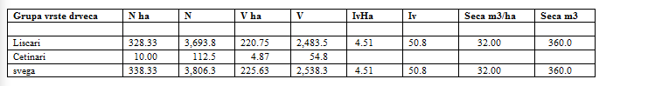
- Starosni koraci
Zahtev: Starosni koraci = novi atribut koji treba omogućiti analizu svih tipova šuma nezavisno od različitih širina dobnih razreda

Kod unosa opisnih podataka, pored dobnog razreda dodata je njegova širina, koja se upisuje kao 5, 10 ili 20. Ovaj podatak omogućava da se kod izrade rekapitulacija odvoje sastojine sa različitim širinama dobnog razreda.

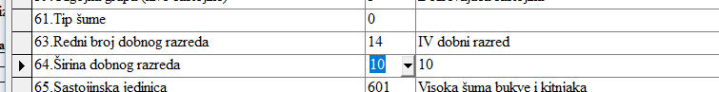

Predlog visko važnih elemenata unapredjenja od strane projektne radne grupe i FIS/GIS tima sa Šumarskog fakulteta

- Proširi na sve vrste drveća
Zahtev: Dozvoliti po vrstama specifične analize
Koristiti postojeće grupisanje po vrstama drveća za standardnu analizu

Ovaj zahtev je identičan zahtevu u poglavlju 11. realizovan je na način kako je tamo objašnjeno.

- Fleksibilnija analiza sa fokusom na vrste drveća
Zahtev: Omogućiti fleksibilnu kombinaciju atributa na nivou drveća, površine i sastojine za izveštaj i analizu

Opcija pregled/rekapitulacije omogućava detaljne analize-rekapitulacije za vrste drveća
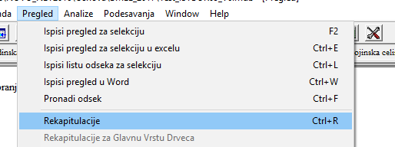

Vrsta drveća se u listi atributa nalazi na poziciji 83. Kombinacijom vrste drveća, sa drugim opisnim atributima za nivo sastojine, mogu se dobiti odgovarajći, detaljni izveštaji.

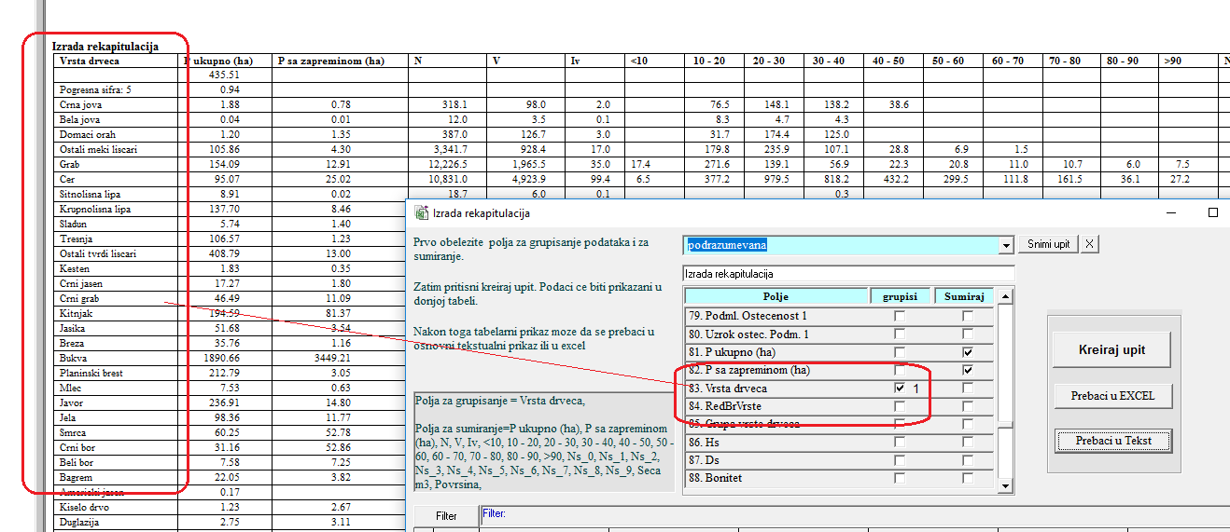

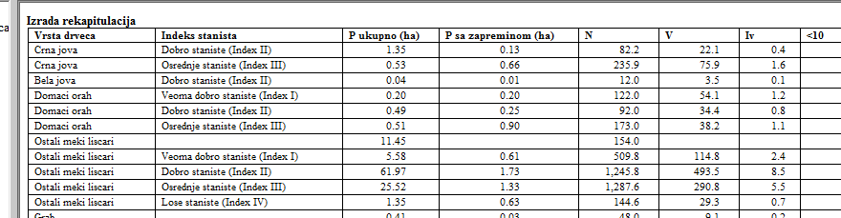

- Poboljšanje pristupa proceni broja stabala po ha i po debljinskoj klasi
Zahtev: Razjasniti korišćeni pristup ako veličina primerne površine varira
Pristup zasnovan na ukupnom broju / ukupna površina ne obezbeđuje objektivne rezultate
Treba koristiti prvo determinaciju n / ha po površini i prosečno po svim površinama

Metodologijom je predvidjeno da svi krugovi u odseku imaju istu površinu.
Površina kruga se unosi kao šifra i to
If SifraKr = 1 Then p = 0.01 ha
If SifraKr = 2 Then p = 0.02 ha
If SifraKr = 3 Then p = 0.05 ha
If SifraKr = 4 Then p = 0.1 ha
If SifraKr = 5 Then p = 0.1 ha

Program ne obavezuje da se metodologija striktno poštuje, odnosno veličina primerne površine može biti drugačije definisana.

Šiframa koje su gore navedene dobbijaju se standardne površine
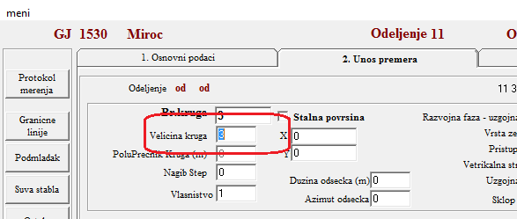

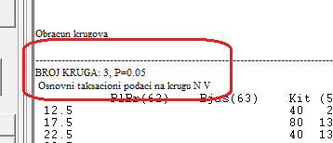

U koliko šifra (fiksna površina) ne zadovoljava potrebe, površina kruga se može uneti kao m².
U koliko se u polju za površinu unesete površina u m² (ne kao ceo broj, odnosno šifra) kao trocifren broj, prgram će istu da prihvati u m².

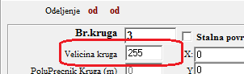

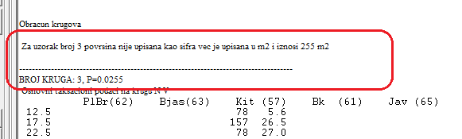

Zapremina i broj stabala se obračunava na način da se za svaku primernu površinu podaci preračunavaju na 1 ha. Nakon toga za nivo odseka se obračunava prosek svih primarnih površina.

Radi kontrole program tokom obrade prikazuje podatke po jednom hektaru za svaku primernu površinu i na kraju prosek za ceo odsek.

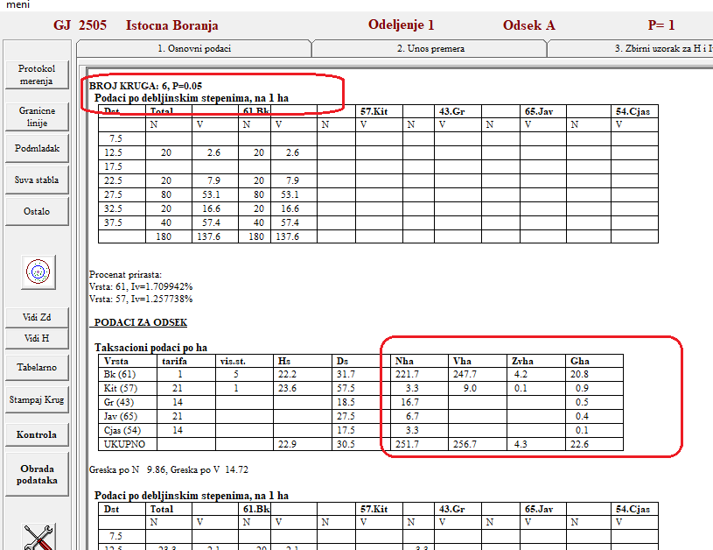

Kod unosa podataka treba obratiti pažnju na nagib primerne površine. U koliko se unese nagib, površina kruga će biti redukovana za vrednost unetog nagiba. U zavisnosti od toga da li je krug na terebu postavljan sa koso merenim prečnikom, ili je prečnik redukovan, nagib se unosi ili ne. Po pravili, prečnik kruga se redukuje na terenu tako da nagib ne treba unositi.

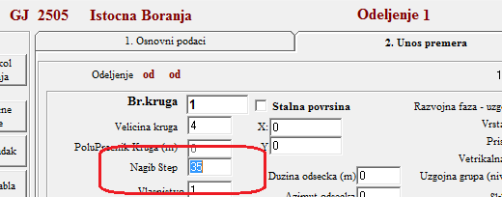

Kod podešavanja parametara za obračun zapremine, dodata je opcija kojom može u potpunosti da se isključi redukovanje prečnika kruga, odnosno redukcija površine kruga u zavisnosti od nagiba.
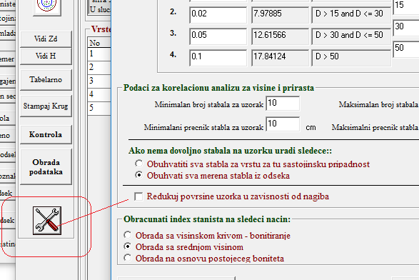

- Poboljšanje pristupa kalkulaciji visine i zapremine
Zahtev: Trenutno postoje dve opcije zapreminske tarifne metode I metod zapreminskih tablica
Nova procedura za opciju zasnovanu na tarifi:
Preporučeno rešenje: Zapreminska tarifna klasa definisana sa h i d odnosom. Identifikovati klasu sa visinama na osnovu h i d u sastojini.
Zapreminske tablice = Funkcije zapremine kao one što se koriste u CG verziji OSNOVA-e. Svako drvo sa izmerenom visinom će biti izračunato na osnovu h i d; Ostatak drveća se računa koristeći visine iz visinske krive za izmereni prečnik, ne za klasu staništa!

Preporučena alternativa:
Identifikovati klasu po sastojini i vrstama identifikovanjem iznosa h i d u okviru klase, koristeći sve izmerene h u sastojini.
Kalkulacijom artitmetičke sredine determiniši se klase:
(Primer sa 5 klasa)
Klasa | N | N *klasa
I | 3 | 3
II | 1 | 2
III | 0 | 0
IV | 5 | 20
V | 1 | 5
Rezultat: 30/10=3
Metod zapreminskih tablica se već primenjuje.
Preporučuje se upotreba zapreminskih tablica za sve vrste drveća za koje su dostupne.

Kada su za način odredjivanja visinskog stepena unete šifre 1 ili 2 formiraju se visinske krive i na osnovu njih se vrši odredjivanje visinskog stepena, uporedjivanjem krive sa bonitetnim snopovima.
Srednja visina se za svaku vrstu drveća odredjuje se na osnovu visine iz visinske krive (upotrebom srednjeg prečnika te vrste)

U cilju bonitiranja sastojine bez predhodne izrade izrade visinske krive, dodata je opcija 4 „Bonitiranje na osnovu srednje visine“

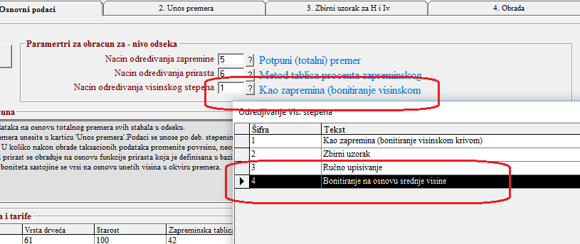

Kod ove obrade se ne formiraju visinske krive već se na osnovu premerenih visina stabala (za datu vrstu) obračunava Hs i Ds. Uporedjivanjem Hs sa visinama iz tarifnih nizova (za stvarni Ds te vrste) odredjuje se visinski stepen vrste.

U ovom slučaju se srednja visina odredjuje kao srednja visina stabala kojima je merena visina. Ovaj podatak nje manje pouzdan jer se srednji prečnik stabala kojima su merene visine ne podudara sa srednjim prečnikom sastojine. U tom sličaju je i visinski stepen određen samo za ona stabla koja imaju merene visine, a ne za sva premerena stabla u sastojini.
Takodje, u ovom slučaju nije formirana visinska kriva i iz tog razloga nije moguće primeniti dvoulazne (d,h) zapreminske funkcije za obračun zapremine. Takodje, zapreminsku funkciju nije moguće koristiti kod obrade doznake stabala za seču. U oba slučaja korisnik je u mogućnosti da koristi samo samo tarife.

- Integracija provere verodostojnosti u unosu podataka- “Logička kontrola”
Zahtev: Navedeni pristup se pominje i u drugim projektima. CG verzija se može koristiki kao primer za dobar pristup.

Podaci se mogu kontrolisati nakon izvršenog unosa podataka, opcijom kontrola podataka. Startovanjem ove opcije se dobija forma u kojoj je potrebno uneti opseg za kontrolu (GJ i odeljenja) kao i tabele (grupe podataka) koje je potrebno kontrolisati.
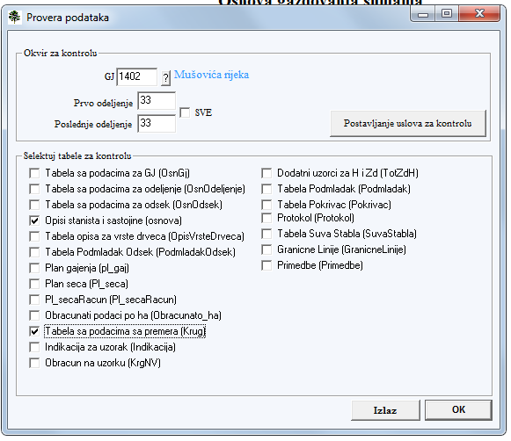

U izveštaju koji se dobije nakon izvršene kontrole prikazuju su greške i upozorenja, koje je potrebno pregledati i prema potrebi izvršiti ispravku unetih podataka.
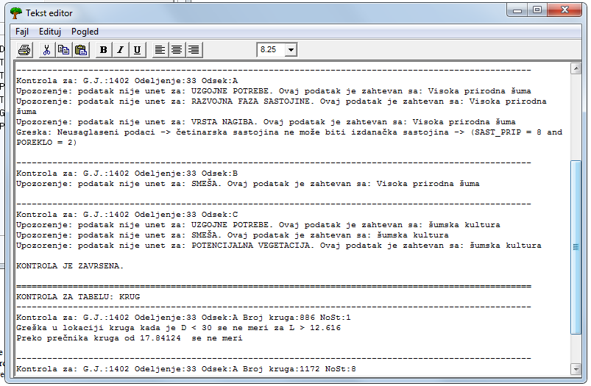

Kontrola podataka se odnosi na sve podatke koji se nalaze u bazi i korisnik može da vrši promene uslova za kontrolisanje podataka.
Promena uslove za vršenje kontrole se može dobiti pritiskom na taster „postavljanje uslova za kontrolu”, nakon čega se dobija sledeća forma:
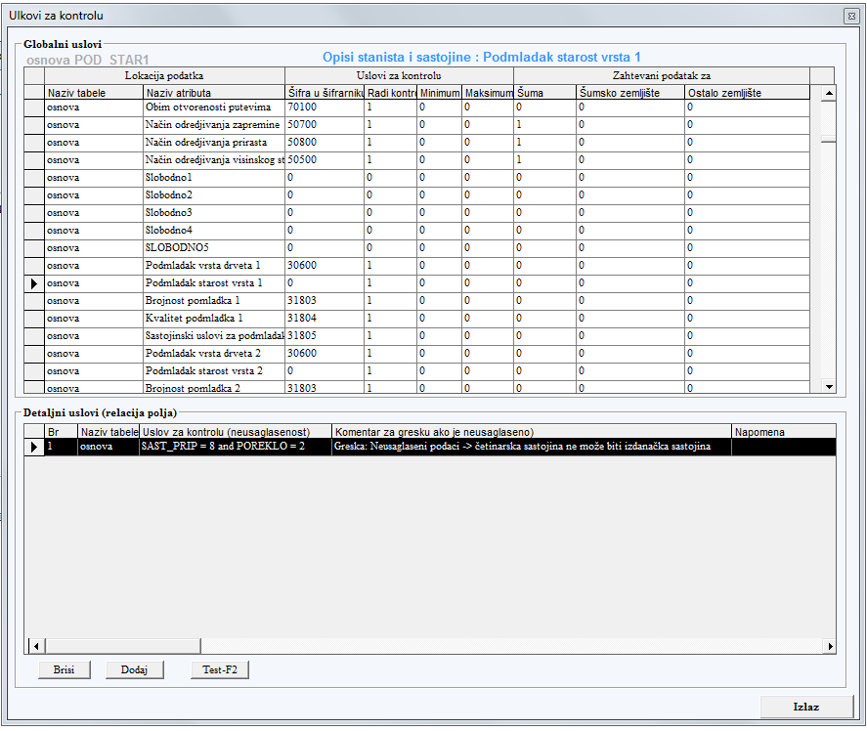

Forma je podeljena u 2 dela. U gornjem delu je prikazan spisak svih polja koja se nalaze u bazi podataka sa zadatim uslovima koji se odnose na to polje.
- Naziv tabele. U ovoj koloni je naziv tabele koja sadrži podatak
- Naziv atributa. Predstavlja naziv atributa, odnosno polja u koje je smešten podatak.
- Šifra u šifrarniku. U koliko je atribut (polje) numerička vrednost koja u šifrarniku ima svoje kodove i opise, upisan je broj atributa po kome se on vodi u šifrarniku.
- Radi kontrolu. U ovom polju korisnik definiše koja aktivnost treba da se sprovede. Postoje 3 mogućnosti:
0 - ne vrši se nikakva kontrola za taj atribut
1 – vrši se kontrola za taj artibut
3 – ne vrši se kontrola već se samo ispisuje podatak. 3 se unosi kada se radi o indikaciji lokacije, kao na promer GJ, odeljenje, odsek, broj stabla, broj kruga i sl.
- Minimum. Unosi se minimalna vrednost za atribut. Ova vrednost se unosi samo u koliko je u pitanju numerički podatak. Vrednost se ne unosi ako se radi o šifri, odnosno u koliko je u koloni šifra u šifrarniku podatak > 0. U koliko je uneti podatak ispod definisane minimalne vrednosti, biće prijavljena greška
- Maksimum. Važi isto kao za minimum. U koliko je uneti podatak veći od ove vrednosti, biće prijavljena greška

Zahtevanost podataka. Ovim se kontroliše da li je atribut neophodno uneti i to u zavisnosti od vrste zemljišta. Vrednost može biti 1 ili 0. (Pripadnost odseka šumi, šumskom zemljištu se odredjuje na osnovu atributa vrsta zemljišta (VRSTA_ZEM))
- Šuma . Ako je vrednost 1, za sve odseke koji su šuma, atribut je zahtevan i kontrola će da prijavi u koliko podatak nije unet
- Šumsko zemljište. Da li je podatak potrebno uneti za šumsko zemljište
- Ostalo zemljište. Zhtevanost podatka za ostala zemljišta.

U donjoj tabele unose se detaljni uslovi za kontrolu. Ovim uslovima se definišu veze izmedju atributa u okviru jedne tabele u bazi podataka. Unose se sledeći podaci:
- Naziv Tabele. Unosi se naziv tabele. Kada se dodaje novi uslov, biće upisan naziv tabele koja je selektovana u gornjem delu
- Uslov za kontrolu (neusaglašenost). Ovde se definisu uslovi za koje podatak nije ispravan. U gornjem primeru je postavljena kontrola za slučaj da je sastojina četinara po poreklu izdanačka, što predstavlja očiglednu grešku.
SAST_PRIP = 8 and POREKLO = 2 (sast.priradnost 8 su sume jele i smrce, a poreklo 2 je izdanačka sastojina.). U koliko se pojavi ovakav podatak, biće prijavljeno kao greška.
- Komentar za grešku (ako je neusaglašeno). Tekst greške, odnosno konflikta medju podacima se unosi u ovo polje. Tako je za dati primer unet sledeći tekst
„Greska: Neusaglaseni podaci -> četinarska sastojina ne može biti izdanačka sastojina”
-------------------------------------------------------------------------------------------------
Kontrola za: G.J.:1402 Odeljenje:33 Odsek:A
Upozorenje: podatak nije unet za: UZGOJNE POTREBE. Ovaj podatak je zahtevan sa: Visoka prirodna šuma
Upozorenje: podatak nije unet za: VRSTA NAGIBA. Ovaj podatak je zahtevan sa: Visoka prirodna šuma
Greska: Neusaglaseni podaci -> četinarska sastojina ne može biti izdanačka sastojina -> SAST_PRIP = 8 and POREKLO = 2
------------------------------------------------------------------------------------------------

- Napomena. Bez funkcije, služi kao komentar za korisnika.

Uslovi za kontrolu povezanosti atributa moga de se definišu korišćenjem greneratora uslova. Kada se nalazite na tabeli u polju Uslov za kontrolu (neusaglašenost) i pritisnete crtl dobićete sledeću formu:
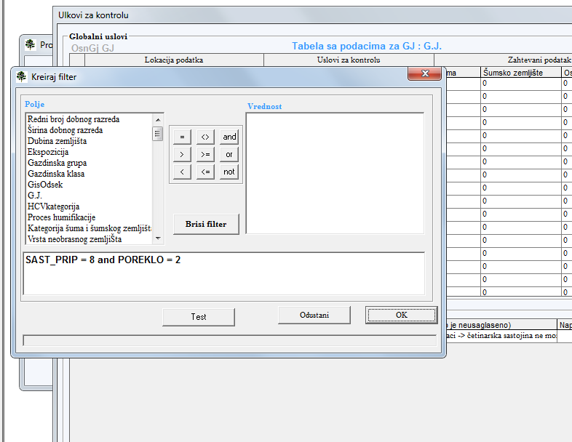

Slična forma se koristi i za definisanje filtera podataka. U levom delu izabrerete polje, zatim operator za uslove i vrednost podatka. Nakon što ste definisali uslov, tasterom test proverite njegovu funkcionalnost. Ako dobijete grešku izvršite korekciju uslova jer isti nije uspravno postavljen. Pritiskom na OK definisan uslov se prenosi u tabelu.
Uslovi koje ste kreirali se smeštaju u bazu šifara, tako da promenom šifrarnika menjate i zadate uslova, odnosno preuzimanjem šifrarnika korisnik dobija nove uslove.
- Prostorni podaci za integraciju RS i mapa
Zahtev:
- Dozvoliti skladištenje GEOM podataka (Poligoni, linije, tačke) u releventnim tabelama (sastojina, krug, drvo)
- Uvesti funkciju za dodadavnje GEOM podataka iz SSV ili SNAPE fajlova
- Integrisati usaglašen set podataka iz RS i mapa

Baza podataka može biti formirana ka GeoDatabase. Program može da formira samo GeoDatabase u MS Access formatu koji je prilagođen za rad sa Esri (ArcMap) formatima. MS SQL server geodatabase jedino može da se formira primenom ArcSDE i ArcCalatog programa kompanije Esri
Prazna Access GeoDatabase može da se kreira opcijom:

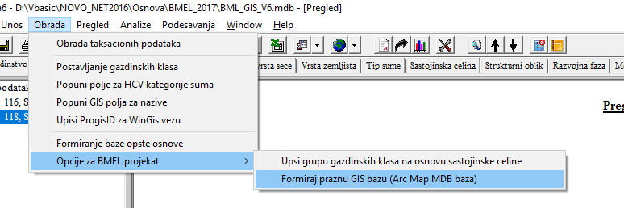

Baza koja je formirana na ovaj nači će sadržati tabele u koje se smeštaju prostorni podaci (granice poligona) za GJ, odeljenje i odsek.

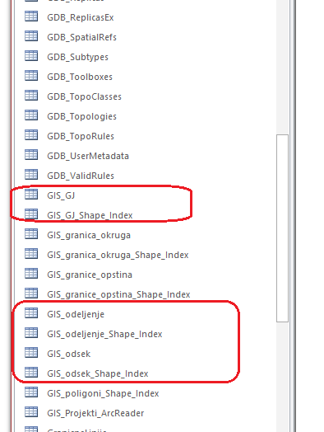

Ovim tabelama se iz programa ArcMap ili ArcCatalog pristupa identično shape (*.shp) fajlovima. U bazi su sadržabe i granice okruga i opština.

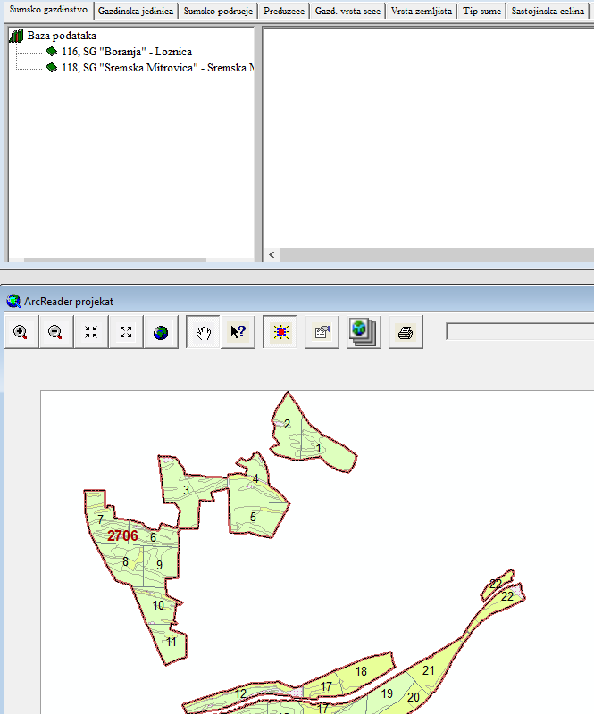

- Dinamična baza podataka, aktualizacija od EVID software i dodavanje novih podataka
Zahtev: Poboljšati postojeće karakteristike radi veće jednostavnosti
Npr. Omogućiti ažuriranje cele baze podataka.

Dinamičko preračunavanje zapremina se vrši na nivou vrste drveta u odseku. Početna za obračun je godina premera, koja je uneta u opisu staništa i sastojina, dok je ciljanu godinu korisnik unosi po želji.

program kalkulaciju može da sprovede na 3 načina:
- U koliko su sprodenene seče i u koliko je baza evidencije seča povezana sa osnovom, program će da doda prirast do godine seče, da oduzme seču i nakon toga da doda progresivno smanjen prirast do ciljne godine.
Program obračunava na sledeći način:
- Izracuna procenat prirasta za svaku vrstu pojedinačno;
- Doda prirast do godine seče, u koliko se seča nalazi u bazi evidencije seča. U koliko seča nije vršena, dodaje prirast do ciljne godine
- Oduzme seču (po vrstama).
- Na osnovu redukovane zapremine primenom procenta Zv izračuna umanjen prirast. nadalje doda umanjen prirast za period od godine seče do ciljne godine
- Bez evidencije seča, samo se dodaje prirast
- Vrši se preračunavanje stabala koja su merena. Na bazi debljinskog prirasta uvećavaju se prečnici svim premerenim stablima.
Nakon uvećanja prečnika, neophodno je da se taksacioni podaci ponovo preračunaju. Ova opcija je za predvidjena za jednu GJ i nije moguće korišćenje za opštu osnovu ili grupu GJ.

Druge opcije koje su urađene na zahtev radne grupe i FIS/GIS tima sa Šumarskog fakulteta

- Bonitiranje na osnovu srednje visine

Kada su za način odredjovanja visinskog stepena unete šifre 1 ili 2 radi se izrada visinske krive i na osnovu nje se vrši odredjivanje visinskog stepena, uporedjivanjem krive sa bonitetnim snopom. Srednja visina se za svaku vrstu odredjuje na osnovu visine iz visinske krive (upotrebom srednjeg prečnika te vrste

Kada je način odredjivanja visinskog stepena 4, ne radi se visinska kriva već se na osnovu srednje visine premerenih stabala (za svaku vrstu), njenim uporedjivanjem sa visinama iz tarifnih nizova (za taj prečnik) odredjije visinski stepen. U ovom slučaju se srednja visina odredjuje kao srednja visina premerenih stabala. U ovom slučaju se srednja visina odredjuje kao srednja visina stabala kojima je merena visina. Ovaj podatak je manje pouzdan jer se srednji prečnik stabala kojima su merene visine ne podudara sa srednjim prečnikom sastojine. U tom sličaju je i visinski stepen određen samo za ona stabla koja imaju merene visine, a ne za sva premerena stabla u sastojini. Takodje, u ovom slučaju nije formirana visinska kriva i iz tog razloga nije moguće primeniti dvoulazne (d,h) zapreminske funkcije za obračun zapremine. Takodje, zapreminsku funkciju nije moguće koristiti kod obrade doznake stabala za seču. U oba slučaja korisnik je u mogućnosti da koristi samo samo tarife.

- indeksi staništa
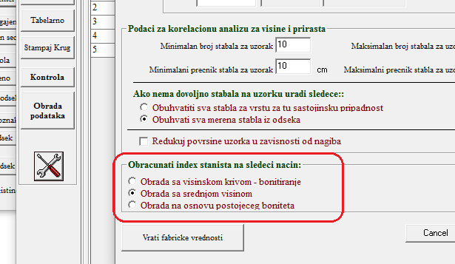

S obzirom da tarife zbog različitog broja visinskih stepena ne ukazuju na produktivnost staništa, ovom opciom se vrši njihovo preračunavanje na način da svaka tarifa bude prikazana kao indeks staništa od 1 do 5.

Način grupisanja je definisan u bazi tarifa u tabeli “BonitetToSiteIndex”

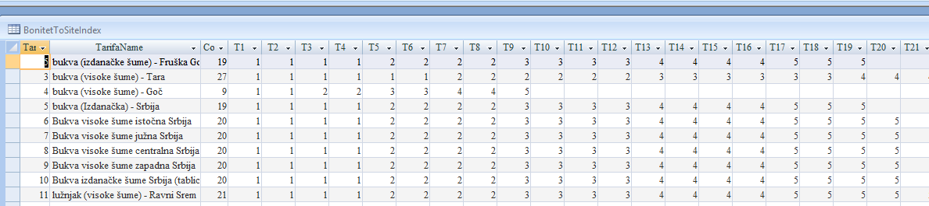

Grupisanje može da se izvrši na 3 načina,
- korišćenjem srednje visine,
- korišćenjem visinske krive
- preračunavanjem na osnovu već obračunatog visinskog stepena.

Navedene metode ne daju u potpunosti identične rezultate ali su razlike zanemarive. Takodje, brzina obrade je različita. Najsporiji obračun je kada se ponovo vrši izrada visinske krive.

Indeks staništa se odredjuje samo za glavnu vrstu.

Za tarifu se ne koriste tarife koje su unete za obradu zapremina, već podrazumevane tarife koje su zadate u bazi tarifa u tabeli “PodrazumevaneTarife”.

Tarifa koja se koristi je zadata u polju “SiteIndex”
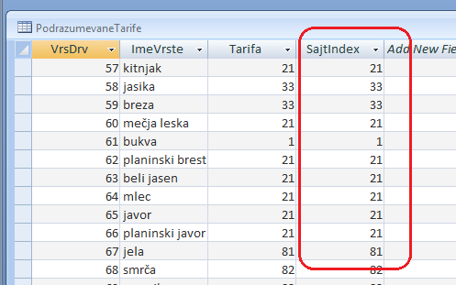

U rekapitulacijama ovaj atribit nosi naziv indeks staništa.

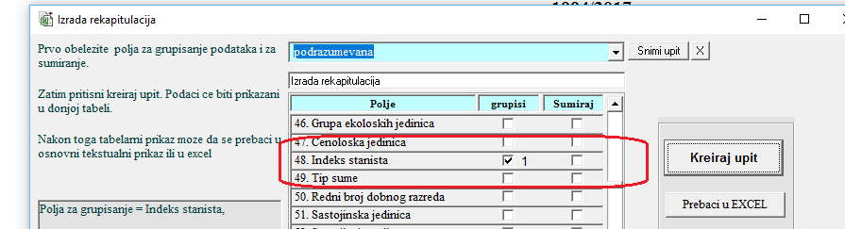

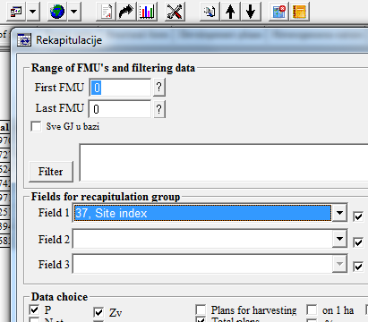

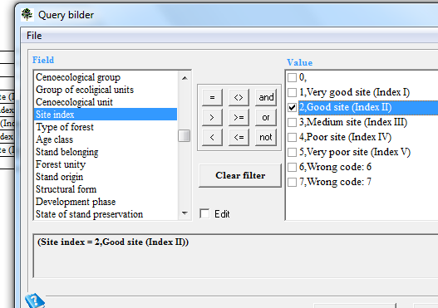

Beograd, 27.06.2017 Dr Aleksandar Vasiljević
Prilog

GIS opcije

Baza podatak za osnove gazdovanja šumama može biti formirana kao GIS database, što omogućuje da u njoj burdu sadržani svi neophodni geografski atributi potrebni za prikazivanje podataka u geografskom obliku. Za ovo je neophodno da Baza podataka sadrži odgovarajuće tabele sa geografskim sadržajem i to:
Tabela GIS_odsek, koja sadrži podatke o obliku (granicama) odseka
Tabela GIS_odeljenje, koja sadrži podatke o granicama odeljenje
Tabela GIS_GJ, koja sadrži podatke o granicama GJ
Ove 3 tabele su neophodne da bi geodatabasa mogla da pravilno radi. Pored ovih tabela sa geografskim podacima, moguce je da se u bazi sadrže i druge tabele za geografsku predstavu (reke, putevi i dr...)
Geografski podaci se u bazu podataka osbove mogu uneti na sledeće načine:
- Da se u bazu podataka koja je formirana osnovom, na osnovu templatea koji je sastavni deo porgrama (opcija fajl/formiraj praznu bazu) unesu neophodne granice programom ArcMap i sl.
- Da se u bazu koju je formirao program osnova učitaju (load) shape fajlovi pomoću programa ArcCatalog u tabele Gis_odsek, GIS_odeljenje i GIS_GJ.
- Da se u bazu podataka osnove koja ne sadrži tabele sa geografskim podacima, učitaju te tabele programom ArcCatalog, koji će bazu dopuniti potrebnim tabelama, i preraditi u oblik geodatabase.
Tabele baze podataka osnove za geografsku predstavu terena moraju da sadrže sledeća polja:
Gis_odsek
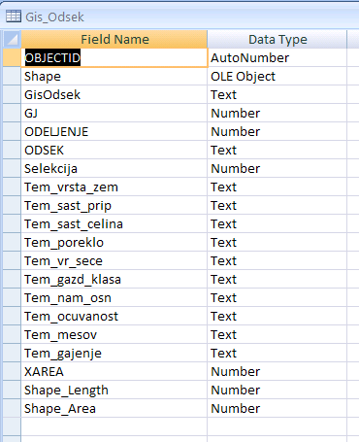

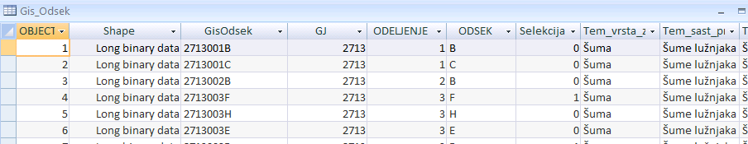

GIS_odeljenje
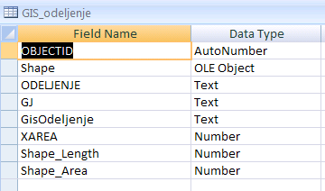

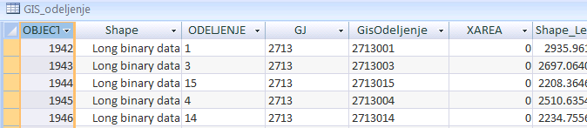

GIS_GJ
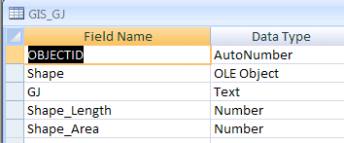

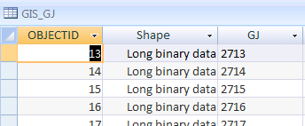

Navedena tabela, po nazivu, tipu i veličini polja moraju da odgovaraju navedenim vrednostima, kako bi program osnova i template projekti za tematske i sastojinske karte mogli da rade.

Takodje polja GisOdsek, GisOdeljenj i GisGj se definišu na sledeći način:
GJ: Šifra GJ 4 znaka
GisOdeljenje: GJ + odeljenje (7 znaka) npr. 1530022 je GJ 1530 odeljenje 22.
GisOdsek: Polje sadrži spojene podatke za GJ+Odeljenje+Odsek (ukupno 9znaka). Neophodno je da GIS projekat za svaki poligon odnosno odsek sadrži identičan ID kao što je to u polju GISodsek.

Na primeru to izgleda ovako
1530003a ovo je gj 1530 odeljenje 3 odsek a
1530033a ovo je gj 1530 odeljenje 33 odsek a
1530333a ovo je gj 1530 odeljenje 333 odsek a
Na isti način se unose i čistine
153003301 ovo je gj 1530 odeljenje 33 cistina 1
153003312 ovo je gj 1530 odeljenje 33 cistina 12
Podaci u tabeli Gis_Odsek čija polja počinju sa TEM_ , se popunjavaju automatski iz osnove i sluče za izradu tematskih karata.
Baza podataka popunjena na navedeni način, omogućava da se programom osnova uspostave odgovarajuće relacije izmedju geografskih i negeografskih podataka koje sadrži baza.

Podešavanje baze podataka pre pokretanja GIS projekata

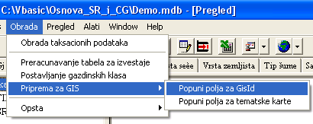
Pre startovanja opcija za GIS projekte, neophodno je startovati dve opcije i to:
- Obrada/priprema za GIS/popuni polja za GisID.
Ovom opcijom se u svim bazama podataka popunjava polje GisOdsek, čija je sadržina i struktura objašnjena kod sadržaja tabela za geografske podatke. Ovim poljem se uspostavljaju relacije izmedju svih geografskih i negeografskih tabela u okviru baze podataka, a koje sadrže podatke o odseku.
- Obrada/priprema za GIS/popuni polja za tematske karte.
Ovom opcijom se u poljima sa prefiksom TEM_ u tabeli Gis_odsek upisuju tekstualni podaci koji su potrebni za izradu tematskih karata. Ovi tekstualni podaci se u osnovi baziraju da kodove iz kodnog priručnika, ali je izvršeno dodatno grupisanje podataka u okviru baze kodnosg priručnika SifreSr.mdb u poljima GisSifra i GisIme. Ovim podacima se vrši grupisanje podataka iz kodnog priručnika za potrebe prikazivanja tematskih karata.

''Развој и увођење иновативног концепта планирања газдовања шумама уз поштовање економских, еколошких) и социјалних аспеката у Србији''
Yokoyama, R. / Shirasawa, M. / Pike, R.J. (2002): Visualizing topography by openness: A new application of image processing to digital elevation models. Photogrammetric Engineering and Remote Sensing, Vol.68, pp.251-266.
Jasiewicza, J., Stepinski, T.F. (2011). Geomorphons - a pattern recognition approach to classification and mapping of Landforms. Geomorphology

